**TravelGo: A Cloud-Powered Real-Time Travel Booking Platform Using AWS**

## Project Description:

TravelsGo is a comprehensive, full-stack, cloud-based travel booking platform designed to simplify the process of reserving buses, trains, flights, and hotels through a unified interface. Built using Flask for backend development, the application is deployed on Amazon EC2 and leverages DynamoDB for efficient storage of user data and bookings. TravelGo allows users to register, log in, search for various transportation and accommodation options, and book their travel with ease. Once a booking is confirmed or cancelled, users receive real-time email notifications powered by AWS Simple Notification Service (SNS), keeping them informed throughout their journey. The platform's user-friendly interface supports dynamic seat selection for buses, hotel filtering based on preferences such as luxury or budget, and provides booking summaries along with centralized cancellation management. By combining cloud scalability, responsive design, and secure session handling, TravelGo delivers a seamless and real-time travel planning experience for users.

**Scenario 1**: Hassle-Free Multi-Mode Travel Booking Experience

TravelGo offers a unified platform for booking buses, trains, flights, and hotels, allowing users to seamlessly plan entire trips. For instance, a user can log in, select their preferred transport, and then book accommodation, all within one interface. Flask efficiently manages real-time retrieval of diverse travel listings and processes user input. Hosted on AWS EC2, the platform remains highly responsive even during peak traffic, ensuring multiple users can browse and book without any delays, providing a truly integrated travel planning experience

### Scenario 2: **Real-Time Booking Confirmation and Updates with AWS SNS**

Upon successful booking, TravelGo instantly notifies the user using AWS SNS, sending real-time email confirmations with all relevant details. For example, after a student books a hotel, they immediately receive an email confirming their reservation. This notification is triggered from the Flask backend once the booking is securely recorded in DynamoDB. AWS SNS can also alert admin staff or service providers, ensuring transparency and real-time updates across all stakeholders for every transaction, from initial booking to any subsequent cancellations

**Scenario 3:** Dynamic User Dashboard with Comprehensive Travel History & Management

TravelGo features a dynamic and personalized user dashboard that provides a comprehensive overview of all past and upcoming bookings. A logged-in user can easily view their flight and hotel reservations, categorized by type, along with essential details like dates and prices. Flask efficiently fetches this personalized data from AWS DynamoDB, which persistently stores all user bookings. The responsive UI, powered by HTML/CSS and Flask templates, ensures users can review, manage, and quickly cancel their bookings anytime, from any device, with real-time updates

**AWS ARCHITECTURE**

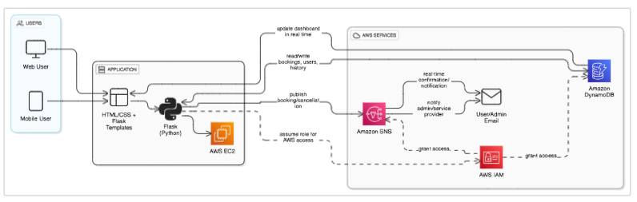

**Entity Relationship (ER)Diagram:**

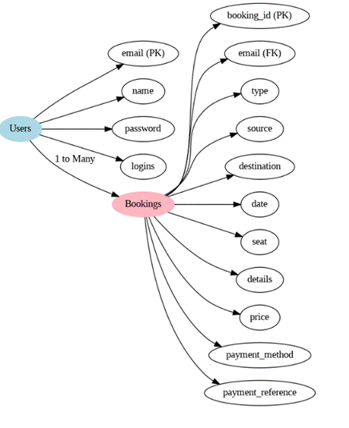

## Pre-requisites:

1. .**AWS Account Setup**:  [AWS Account Setup](https://youtu.be/CjKhQoYeR4Q?si=ui8Bvk_M4FfVM-Dh)
2. **Understanding IAM**:  [IAM Overview](https://youtu.be/gsgdAyGhV0o?si=3qg-bULgkD4LXNvR)
3. **Amazon EC2 Basics**: [EC2 Tutorial](https://youtu.be/8TlukLu11Yo?si=MUj0nEAOESRhHUIz)
4. **DynamoDB Basics**:  [DynamoDB Introduction](https://docs.aws.amazon.com/dynamodb)
5. **SNS Overview**:  [SNS Documentation](https://docs.aws.amazon.com/sns)
6. **Git Version Control**: [Git Documentation](https://git-scm.com/doc)

## Project WorkFlow:

**1.** **Backend Development and Application Setup**

**Activity 1.1:** Develop the Backend Using Flask.

**Activity 1.2:** Integrate AWS Services Using boto3

**2. . AWS Account Setup and Login**

**Activity 2.1**: . AWS Account Setup and Login

**Activity 2.2**: Log in to the AWS Management Console.

**3.** **DynamoDB Database Creation and Setup**

**Activity 3.1**: Create a DynamoDB Table.

**Activity 3.2**: Configure Attributes for User Data and Book Requests.

4. **SNS Notification Setup**

**Activity 4.1**: Create SNS topics for book request notifications.

**Activity 4.2**: Subscribe users and library staff to SNS email notifications.

### 5. IAM Role Setup

**Activity 5.1**: Create IAM Role

**Activity 5.2**: Attach Policies

### 6. EC2 Instance Setup

**Activity 6.1**: Launch an EC2 instance to host the Flask application.

**Activity 6.2**: Configure security groups for HTTP, and SSH access.

### 7. Deployment on EC2

**Activity 7.1**:Upload Flask Files

**Activity 7.2**: Run the Flask App

### 8. Testing and Deployment

**Activity 8.1**: Conduct functional testing to verify user registration, login, book requests, and notifications.

# Milestone 1: AWS Account Setup and Login

**This is for your understanding only, please refrain from creating an AWS account. A temporary account will be provided via Troven.**

* Go to the AWS website (<https://aws.amazon.com/>).
* Click on the "Create an AWS Account" button.
* Follow the prompts to enter your email address and choose a password.
* Provide the required account information, including your name, address, and phone number.
* Enter your payment information. (Note: While AWS offers a free tier, a credit card or debit card is required for verification.)
* Complete the identity verification process.
* Choose a support plan (the basic plan is free and sufficient for starting).
* Once verified, you can sign in to your new AWS accounts.

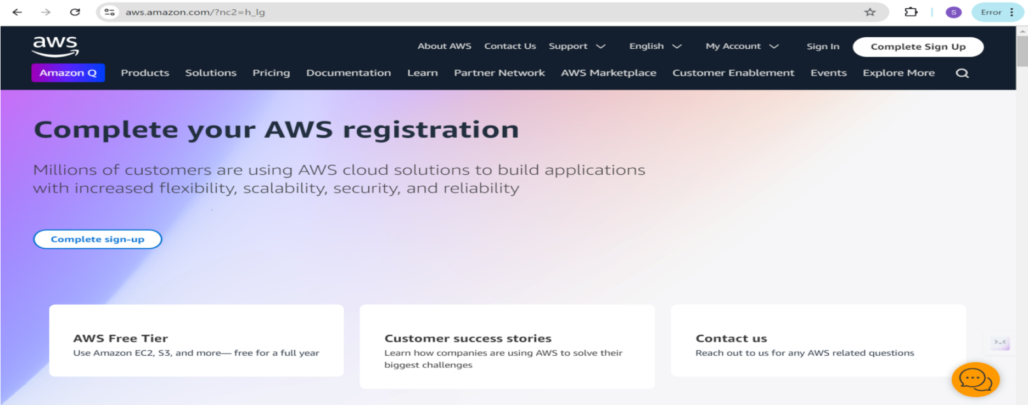

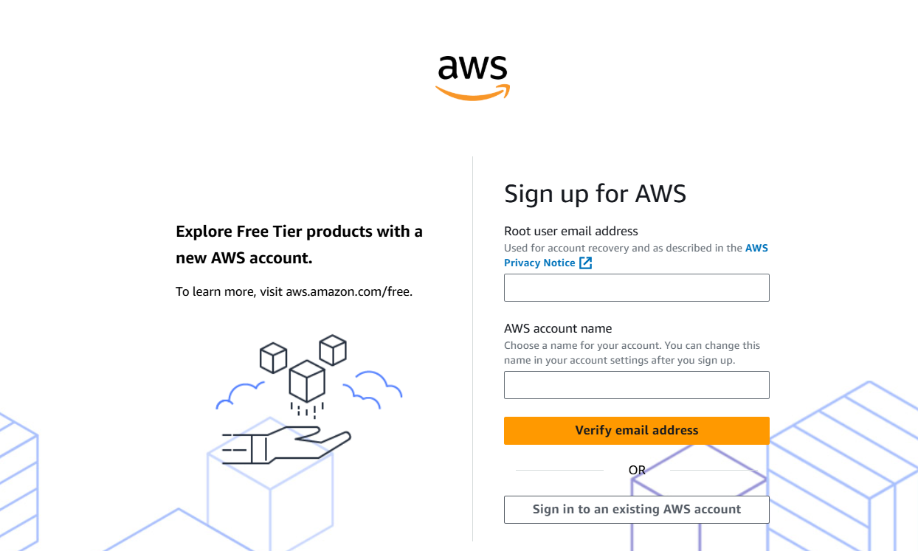

### ● Activity 1: Log in to the AWS Management Console

○ After setting up your account, log in to th[e AWS Management Console](https://aws.amazon.com/console/).

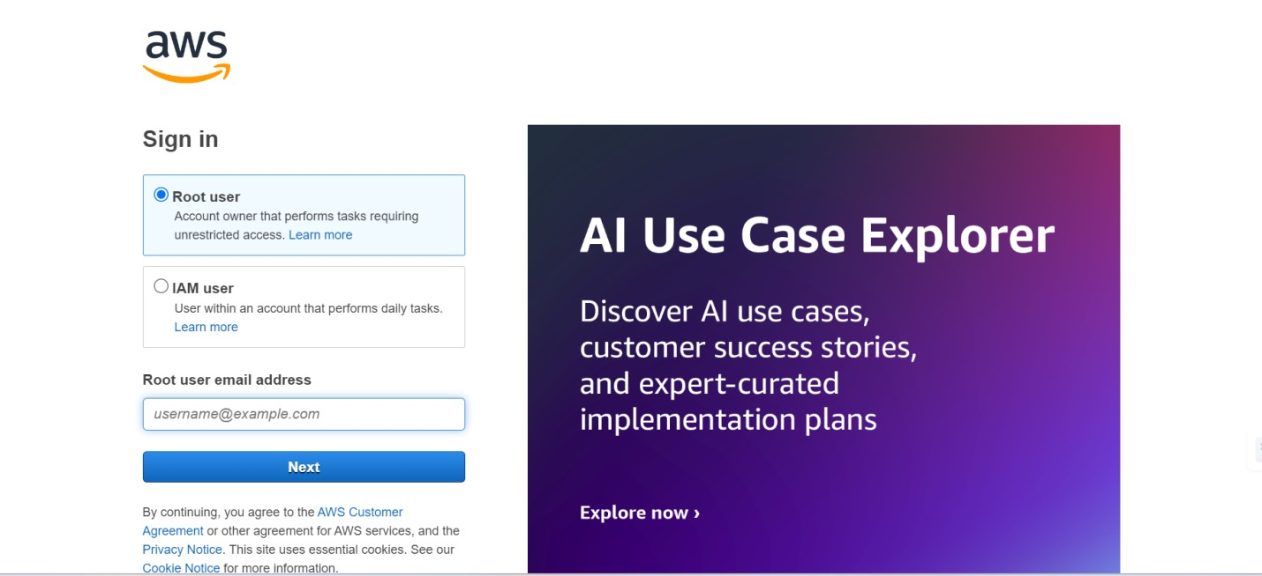

# Milestone 2: DynamoDB Database Creation and Setup

Database Creation and Setup involves initializing a cloud-based NoSQL database to store and manage application data efficiently. This step includes defining tables, setting primary keys, and configuring read/write capacities. It ensures scalable, high-performance data storage for seamless backend operations.

### ● Activity 2.1: Navigate to the DynamoDB

○ In the AWS Console, navigate to DynamoDB and click on create tables.

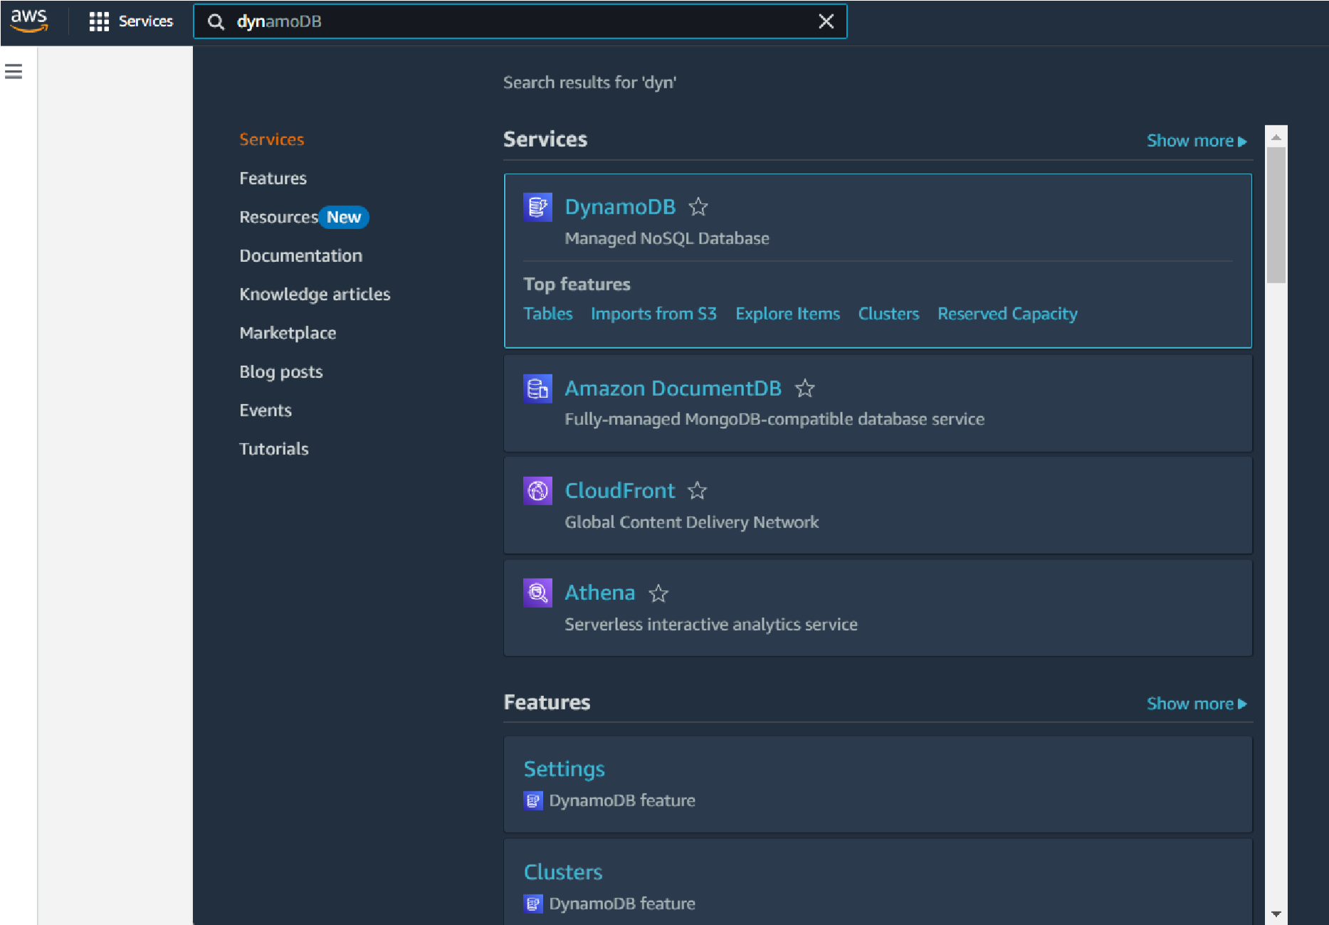

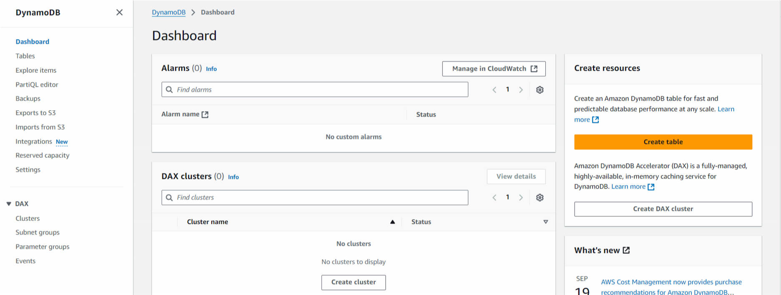

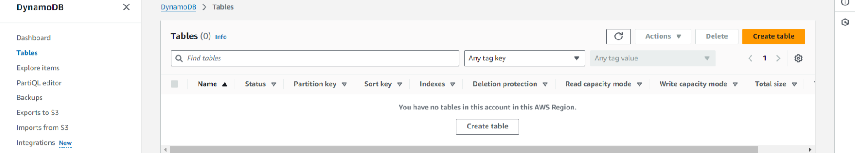

### ● Activity 2.2: Create a DynamoDB table for storing registration details and book requests.

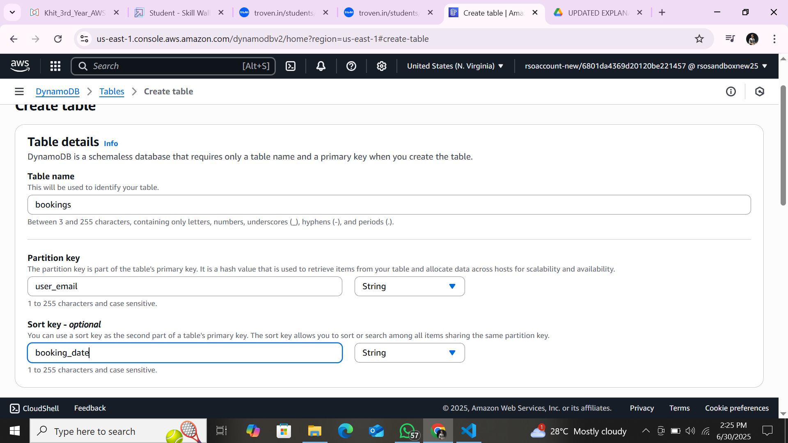

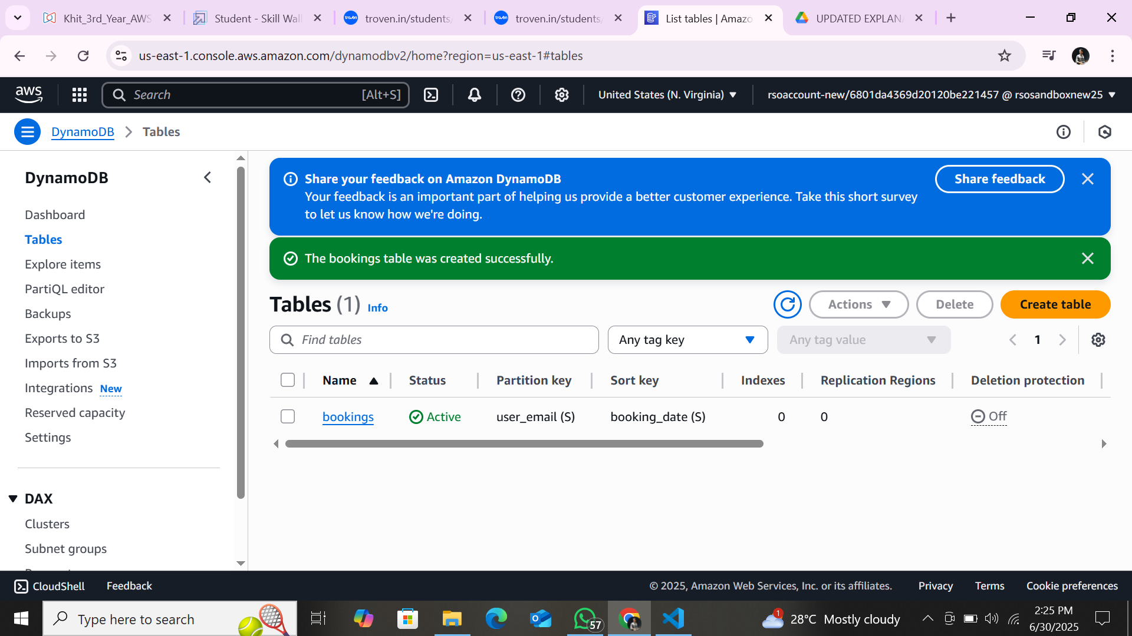

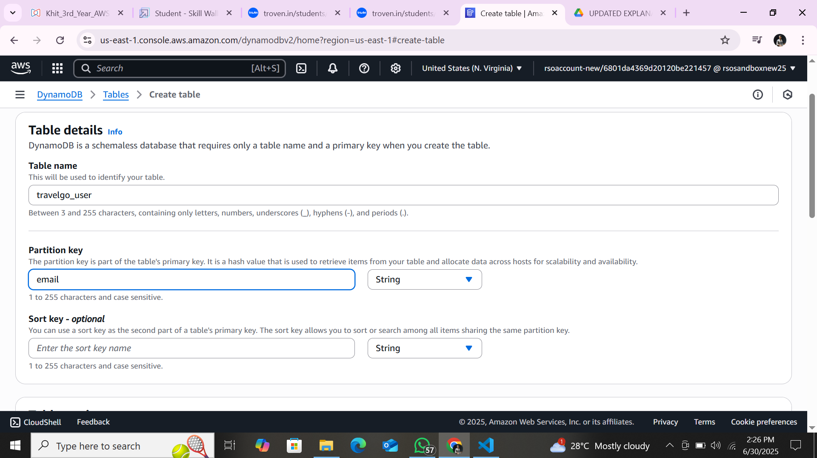

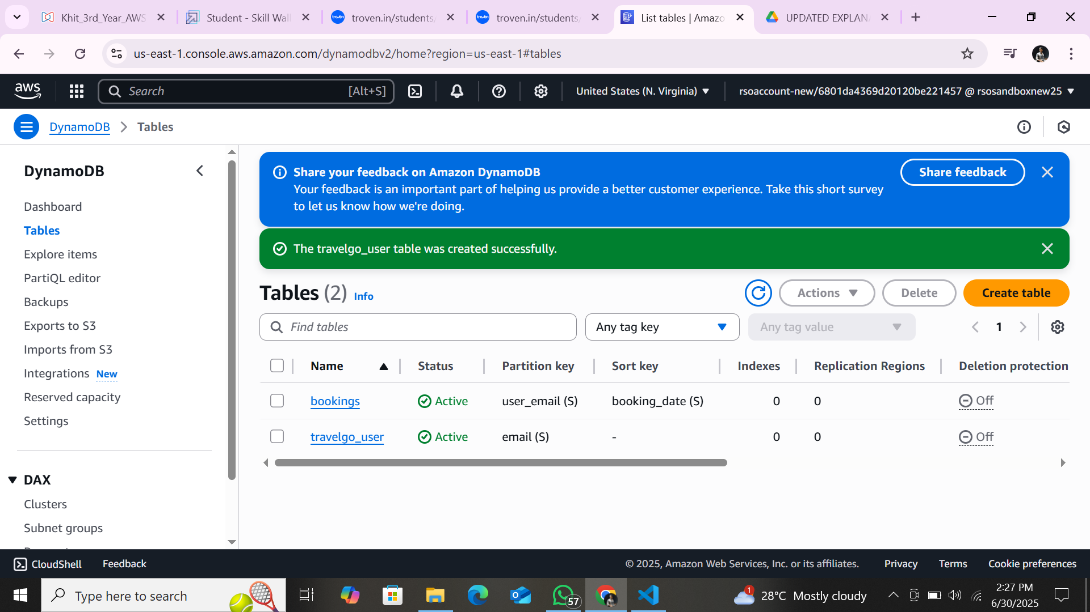

I created three dynamo Tables for my project they are bookings, trains and travelgo user **.**

**Milestone 3: SNS Notification Setup**

### Activity 3.1: Create SNS topics for sending email notifications to users and library staff.

○ In the AWS Console, search for SNS and navigate to the SNS Dashboard.

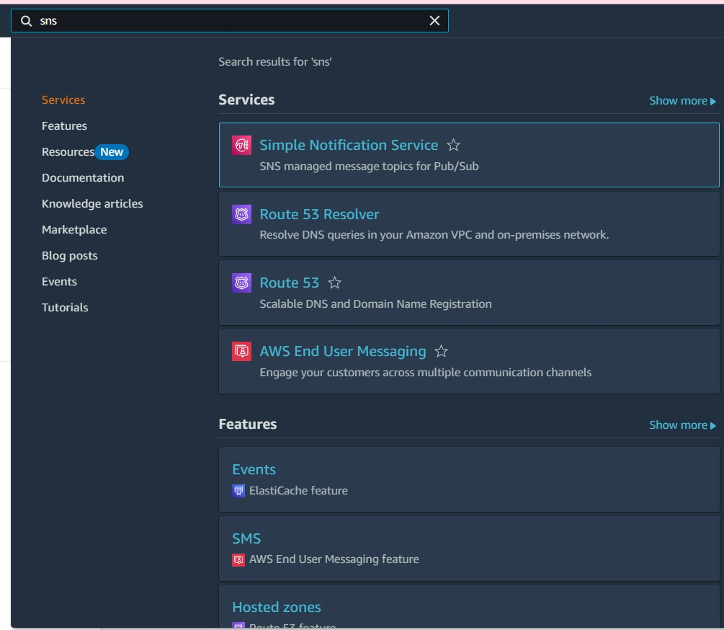

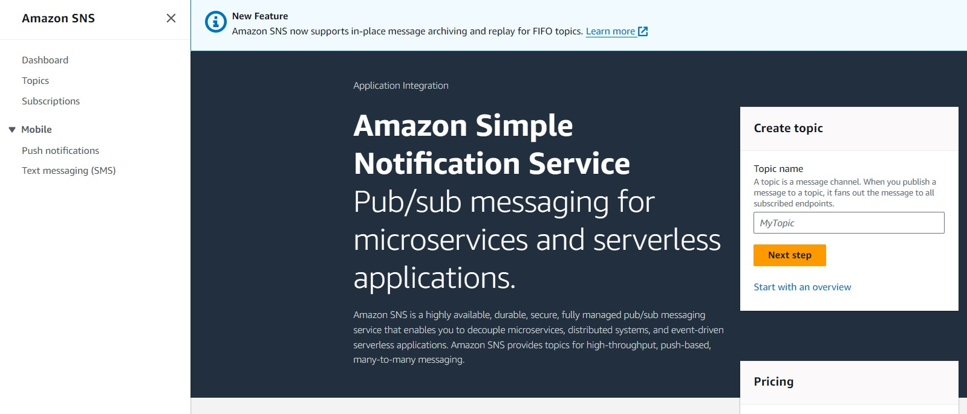

○ Click on **Create Topic** and choose a name for the topic

○ Choose Standard type for general notification use cases and Click on Create Topic.

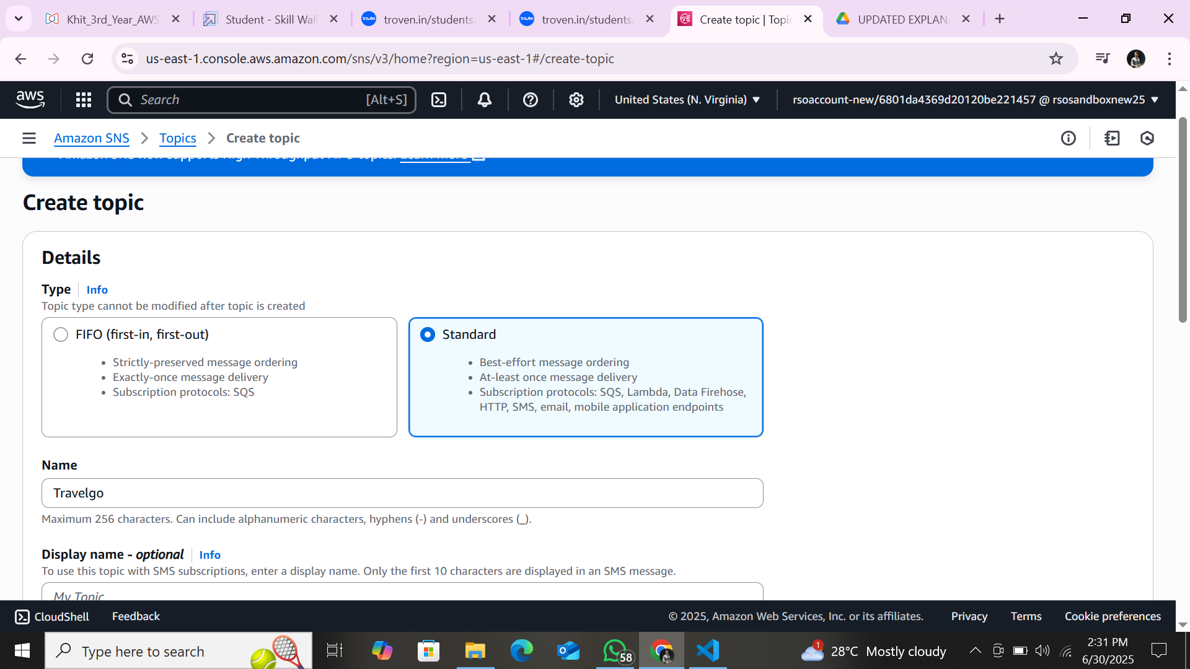

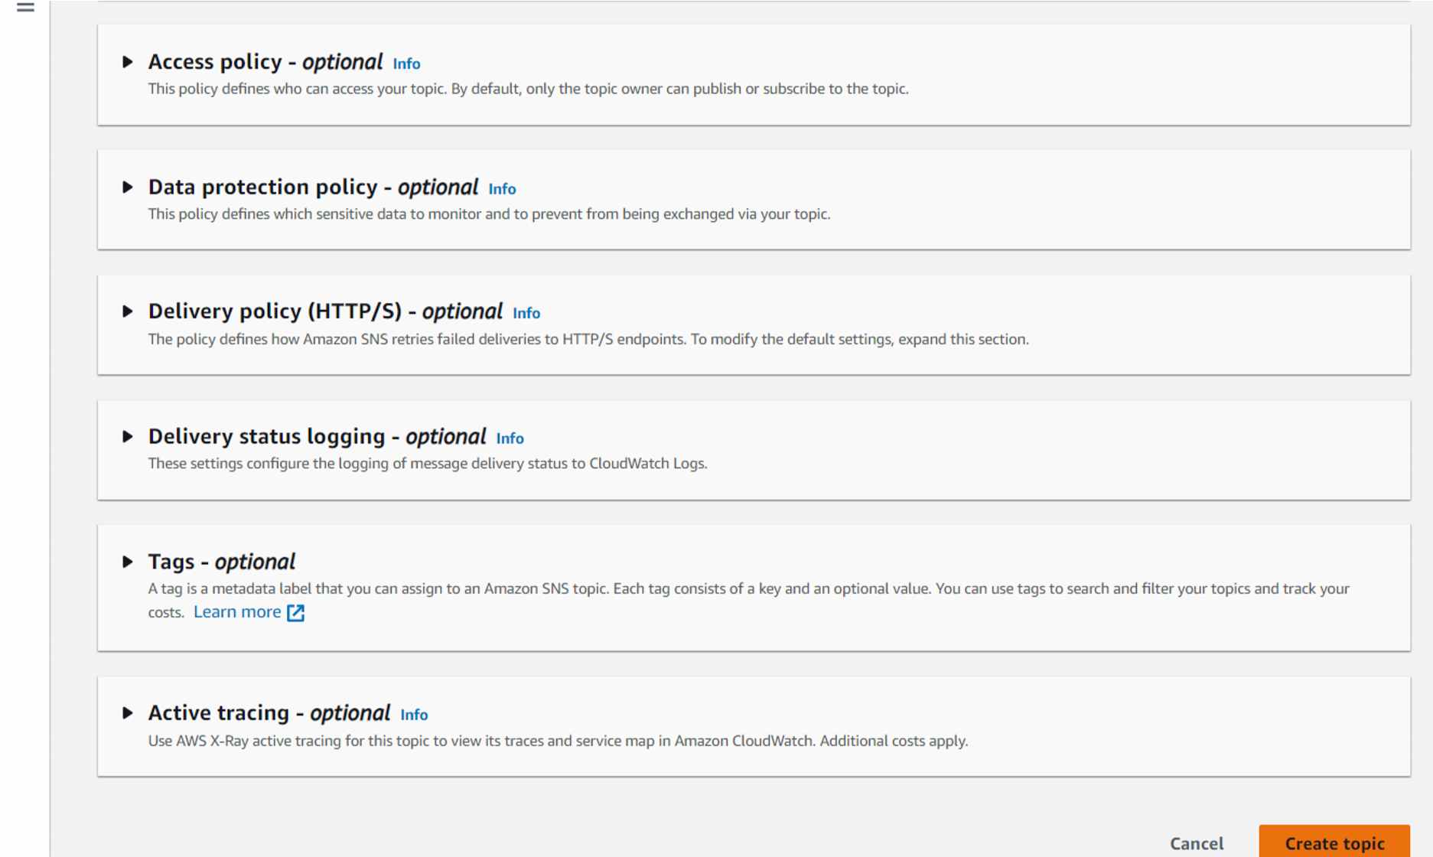

○ Configure the SNS topic and note down the **Topic ARN**.

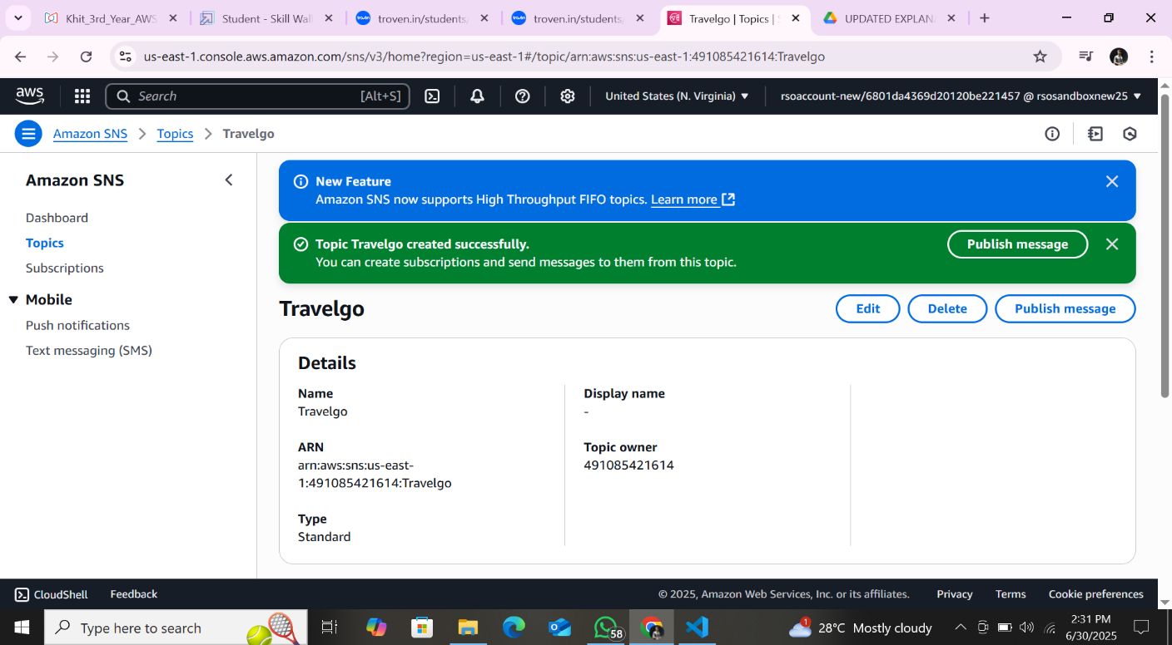

### ● Activity 3.2: Subscribe users and staff to relevant SNS topics to receive real-time notifications when a book request is made.

○ Subscribe users (or admin staff) to this topic via Email. When a book request is made, notifications will be sent to the subscribed emails**.**

○ After subscription request for the mail confirmation

○ Navigate to the subscribed Email account and Click on the confirm subscription in the AWS Notification- Subscription Confirmation mail.

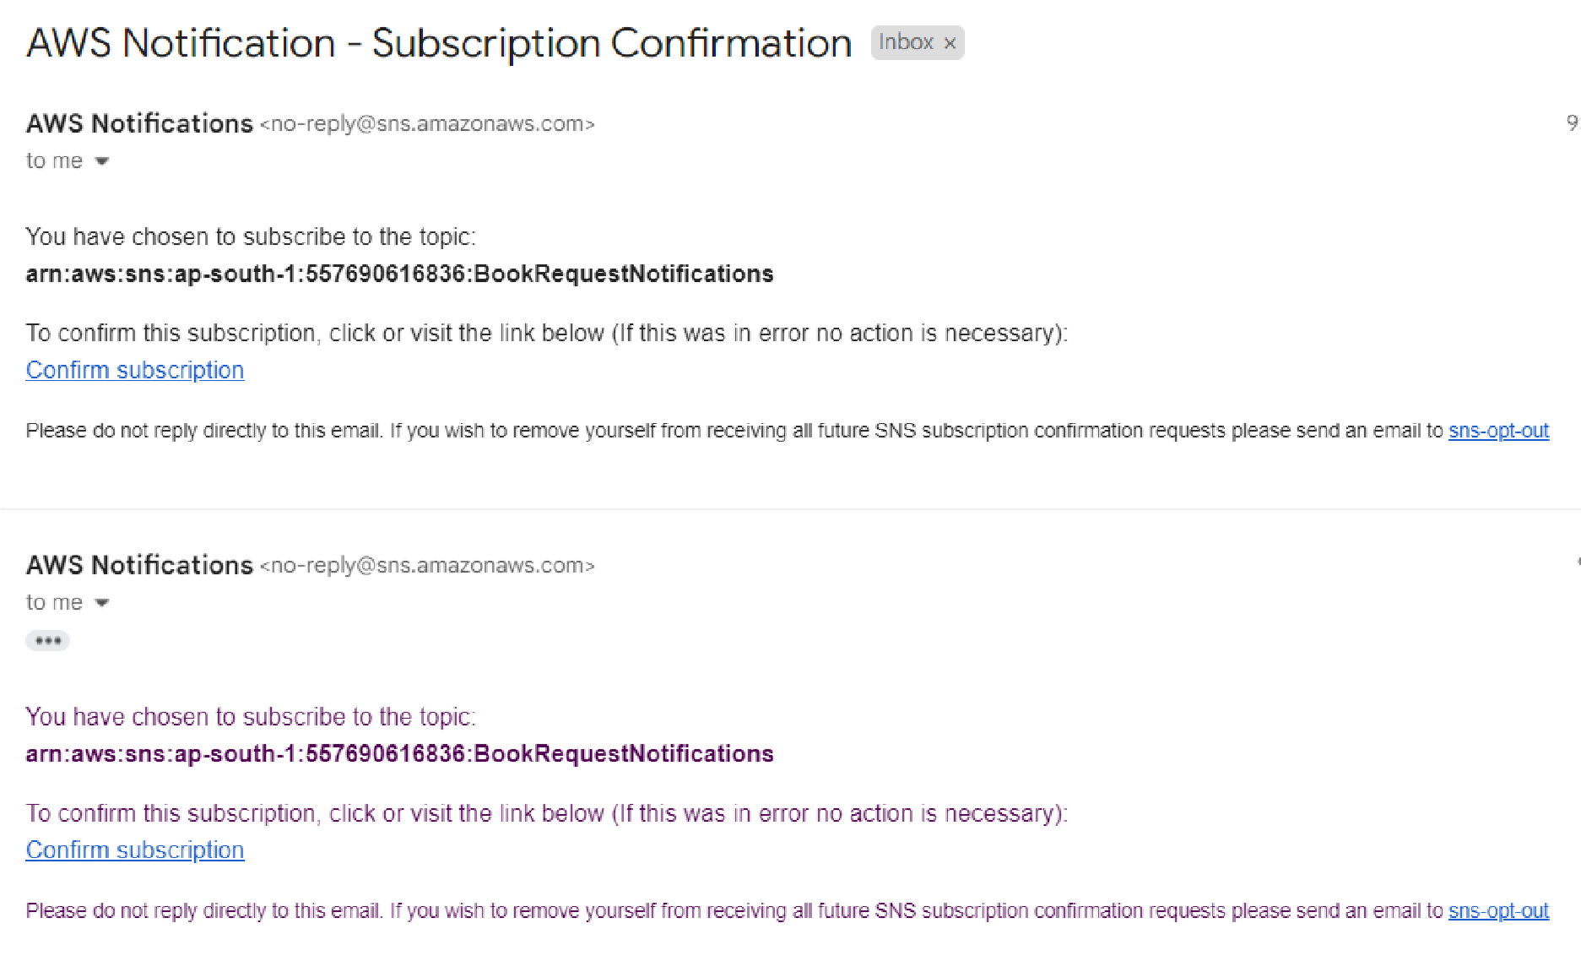

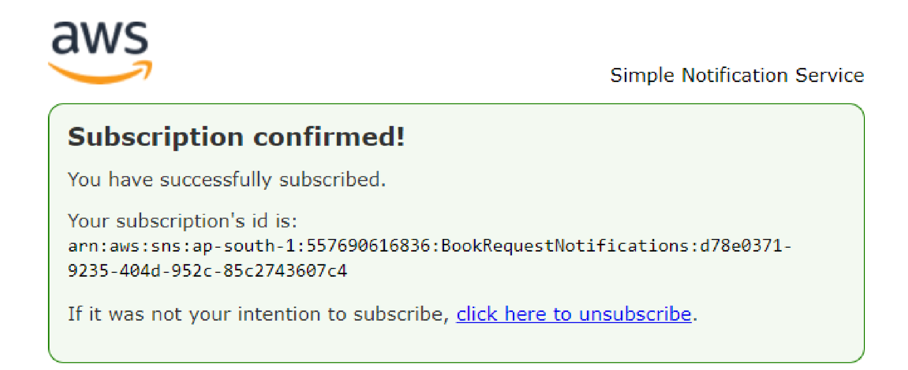

○ Successfully done with the SNS mail subscription and setup, now store the ARN link.

# Milestone 4:Backend Development and Application Setup

### ● Activity 4.1: Develop the backend using Flask

○ File Explorer Structure

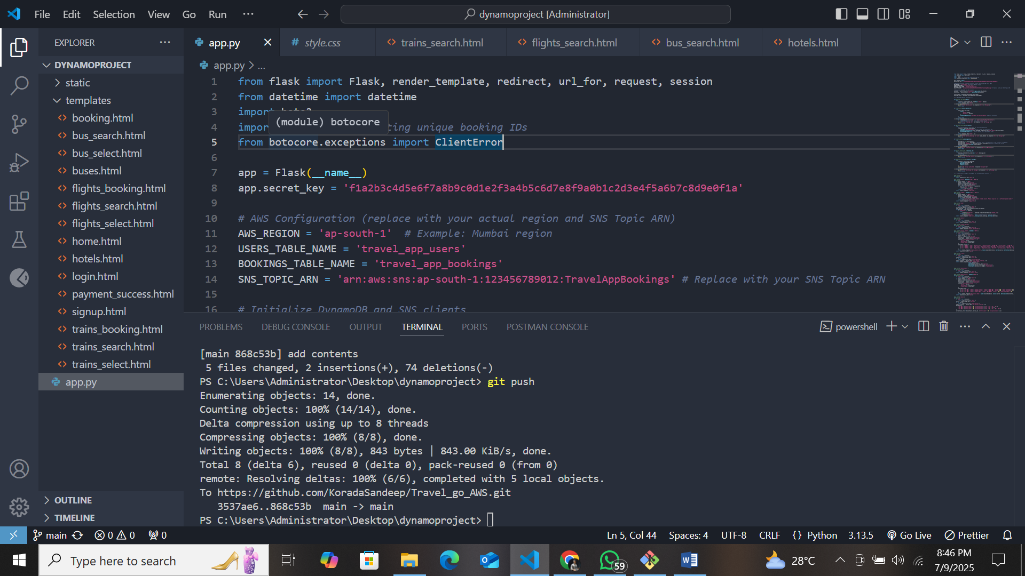

**Description:** set up the TRAVEL GO project with an app.py file, a static/ folder for assets, and a templates/ directory containing all required HTML pages like home, login, register, subject-specific pages (e.g. buse.html, hotel.html, train.html, flight.html).

## Description of the code :

### ● Flask App Initialization

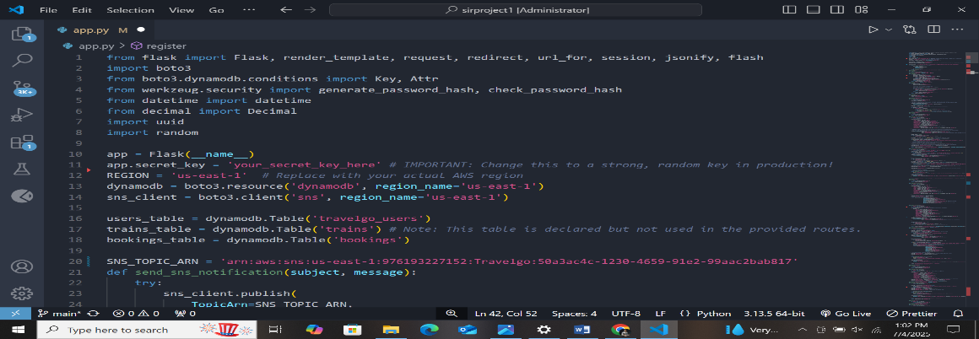

**Description:** import essential libraries including Flask utilities for routing, Boto3 for DynamoDB operations, SMTP and email modules for sending mails, and Bcrypt for password hashing and verification

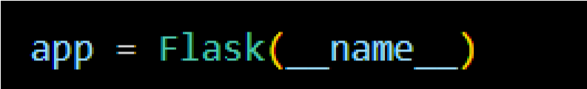

**Description:** initialize the Flask application instance using Flask(__name__) to start building the web app.

● Dynamodb Setup:

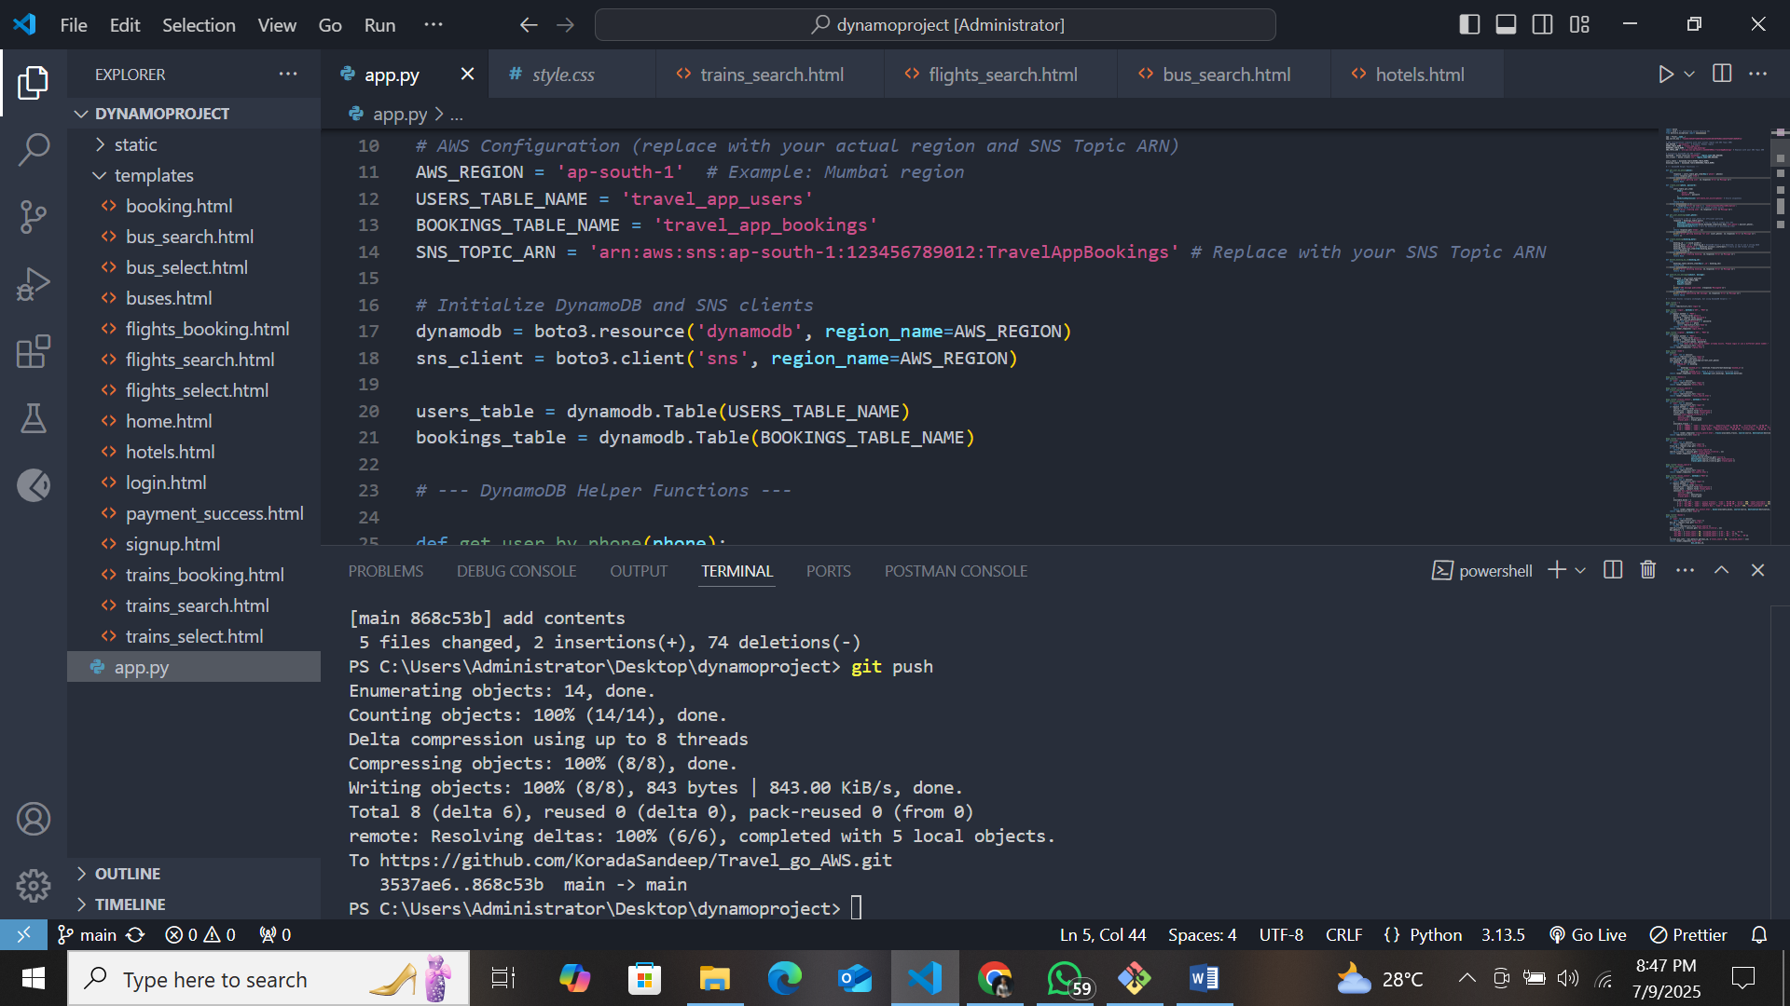

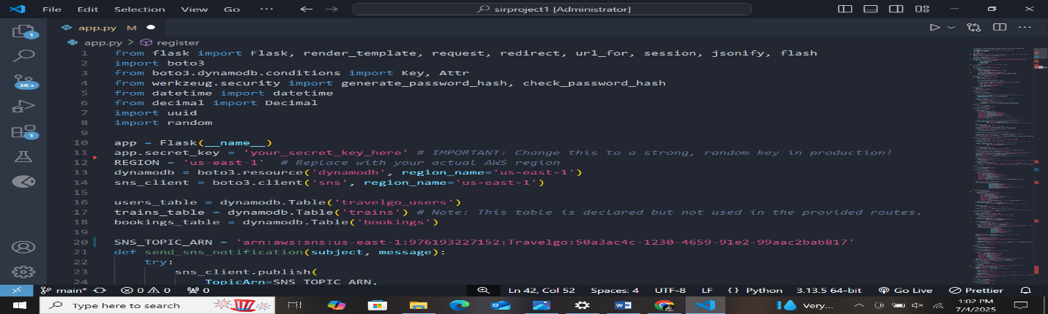

**Description:** Initialize the DynamoDB resource for the us-east-1 region and set up access to the Users and Requests tables for storing user details and book requests.

### ● SNS Connection

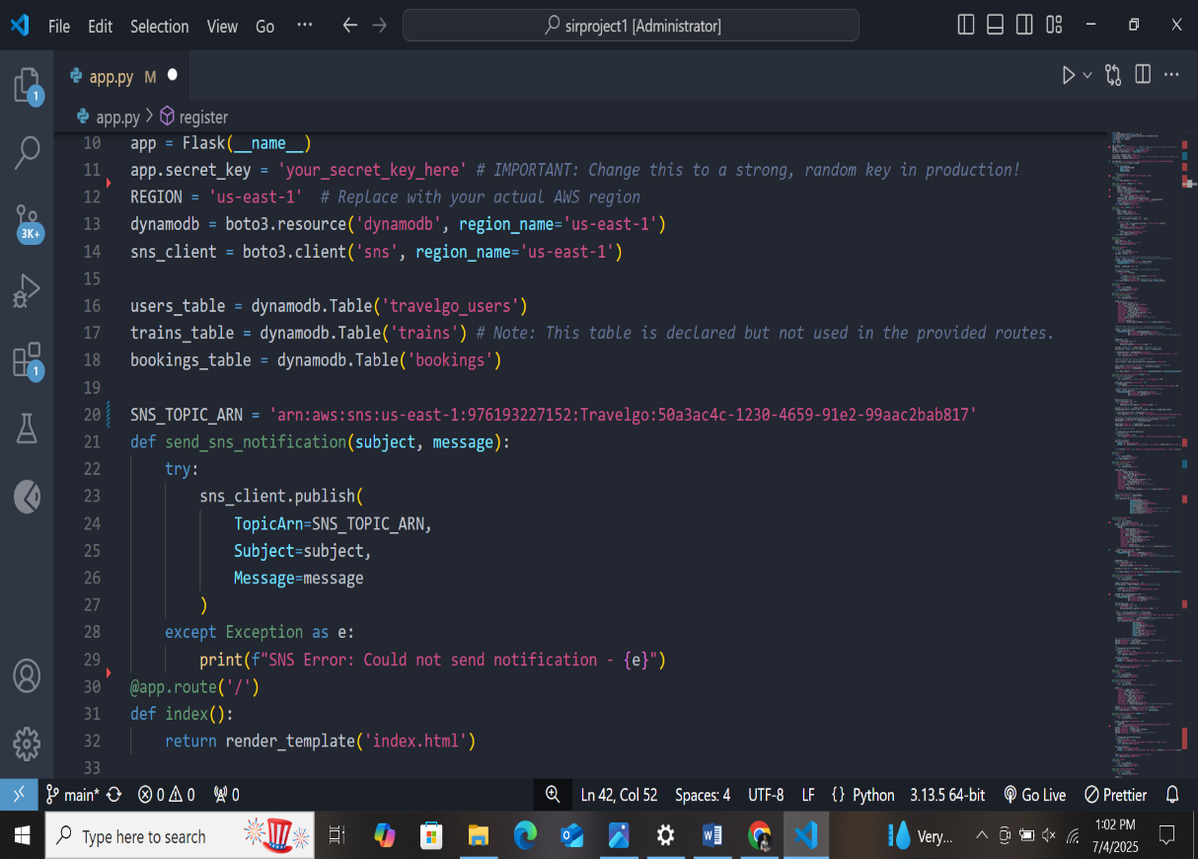

**Description:** Configure **SNS** to send notifications when a book request is submitted. Paste your stored ARN link in the sns_topic_arn space, along with the region name where the SNS topic is created. Also, specify the chosen email service in SMTP_SERVER (e.g., Gmail, Yahoo, etc.) and enter the subscribed email in the SENDER_EMAIL section. Create an ‘App password’ for the email ID and store it in the SENDER_PASSWORD section. **● Routes for Web Pages**

### ● Home Route:

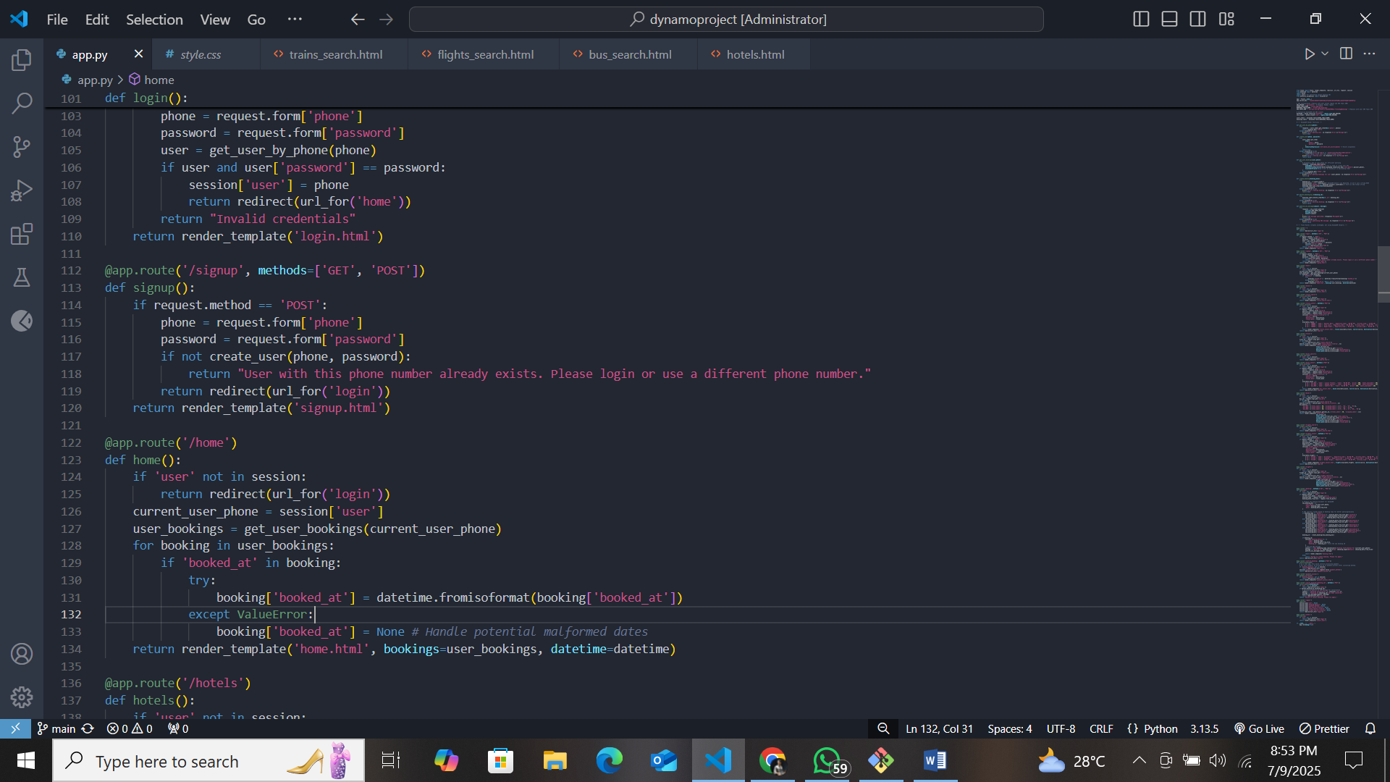

**Description:** define the home route / to automatically redirect users to the register page when they access the base URL.

### ● Register Route:

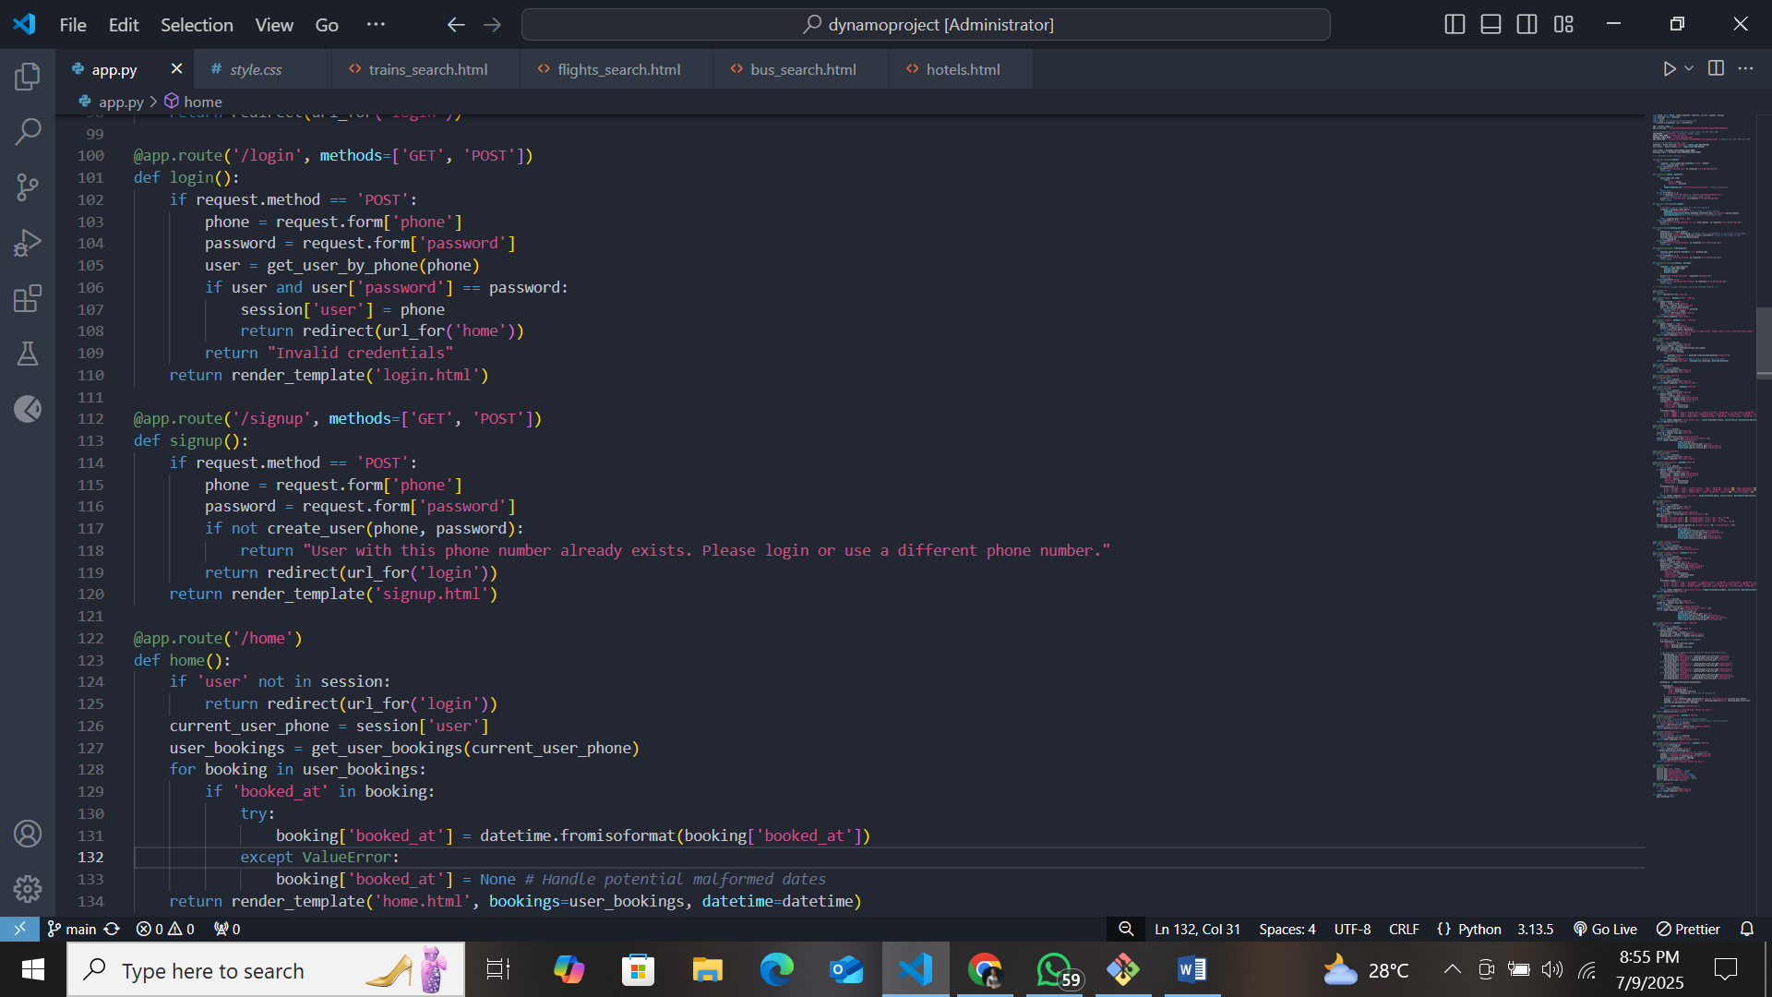

**Description:** define /register route to validate registration form fields, hash the user password using Bcrypt, store the new user in DynamoDB with a login count, and send an SNS notification on successful registration

### ● login Route (GET/POST):

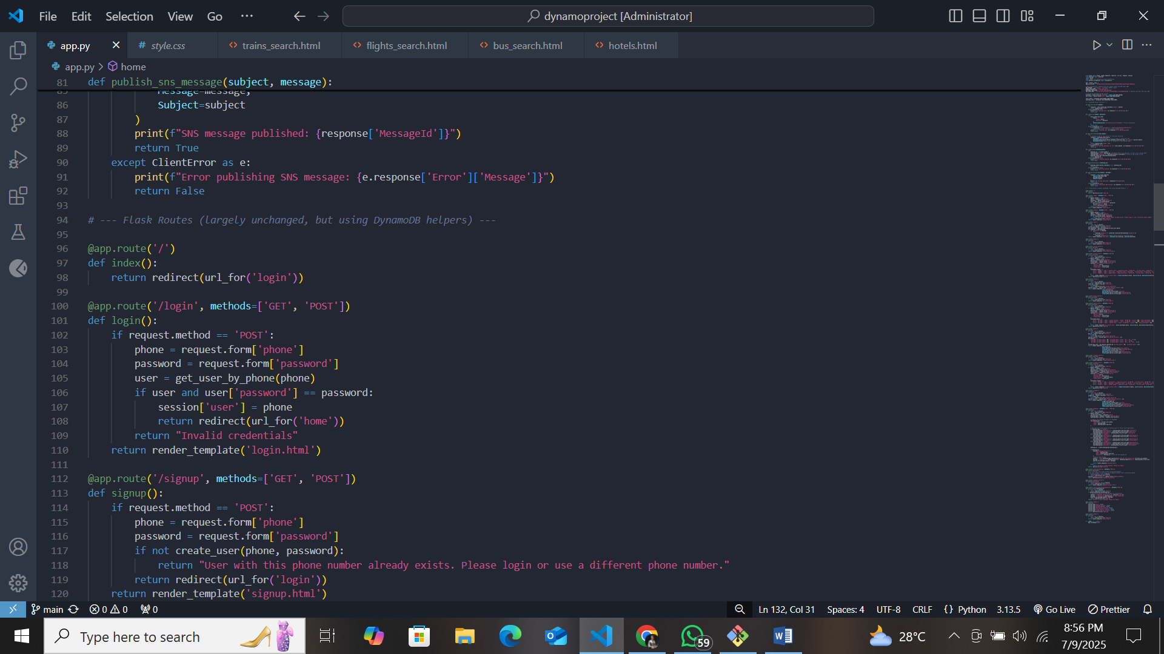

**Description:** define /login route to validate user credentials against DynamoDB, check the password using Bcrypt, update the login count on successful authentication, and redirect users to the home page

### ● Train , Bus and Hotel routes:

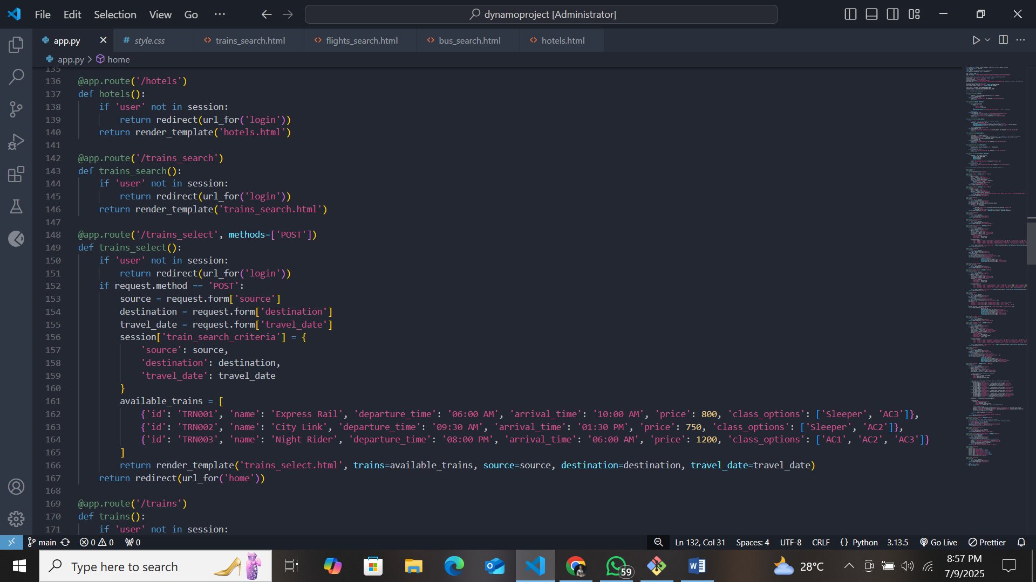

**Description:** define /home-page to render the main homepage, /ebook-buttons to handle subject selection and redirection, and /<subject>.html dynamic route to render subject-specific pages like Mathematics or English.

* **Request Routes:**



**Description:** define /request-form route to capture book request details from users, store the request in DynamoDB, send a thank-you email to the user, notify the admin, and confirm submission with a success message.

**Deployment Code:**

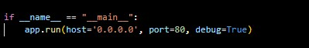

**Description:** start the Flask server to listen on all network interfaces (0.0.0.0) at port 80 with debug mode enabled for development and testing.

# Milestone 5: IAM Role Setup

### ● Activity 5.1:Create IAM Role.

○ In the AWS Console, go to IAM and create a new IAM Role for EC2 to interact with DynamoDB and SNS.

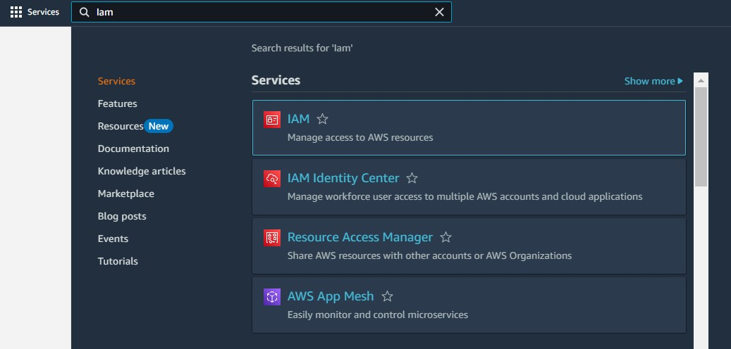

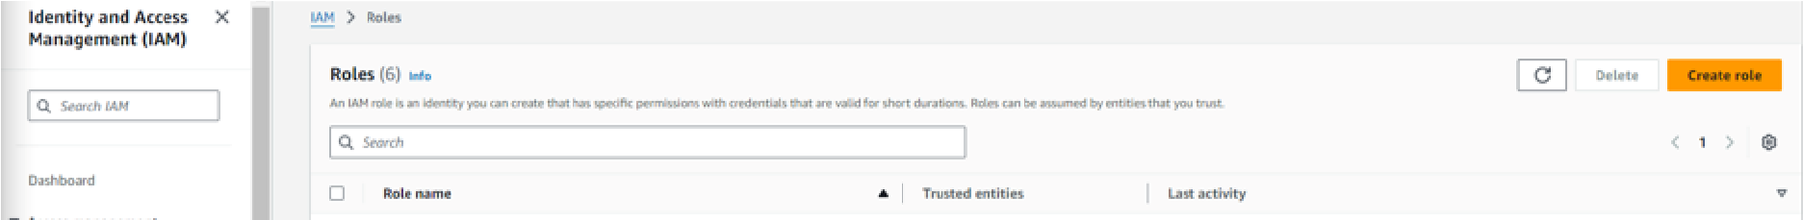

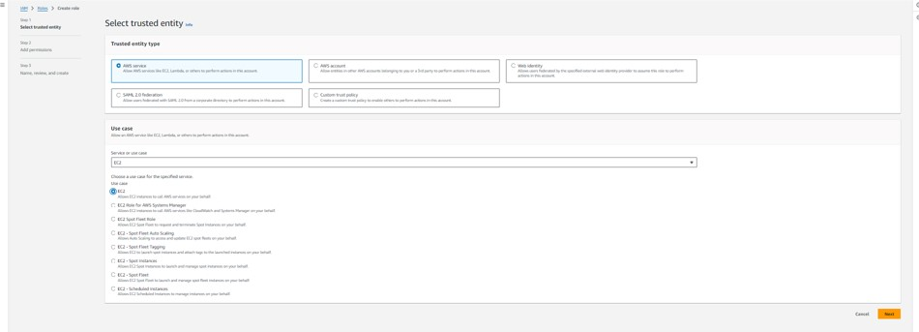

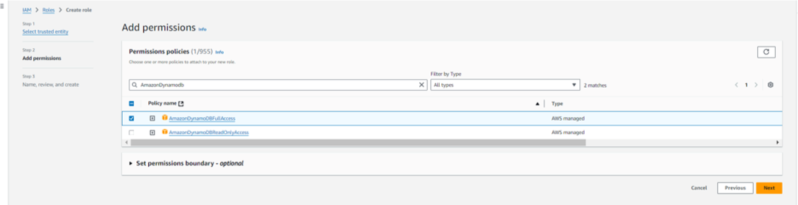

### ● Activity 5.2: Attach Policies.

Attach the following policies to the role:

* AmazonDynamoDBFullAccess: Allows EC2 to perform read/write operations on DynamoDB.
* AmazonSNSFullAccess: Grants EC2 the ability to send notifications via SNS.

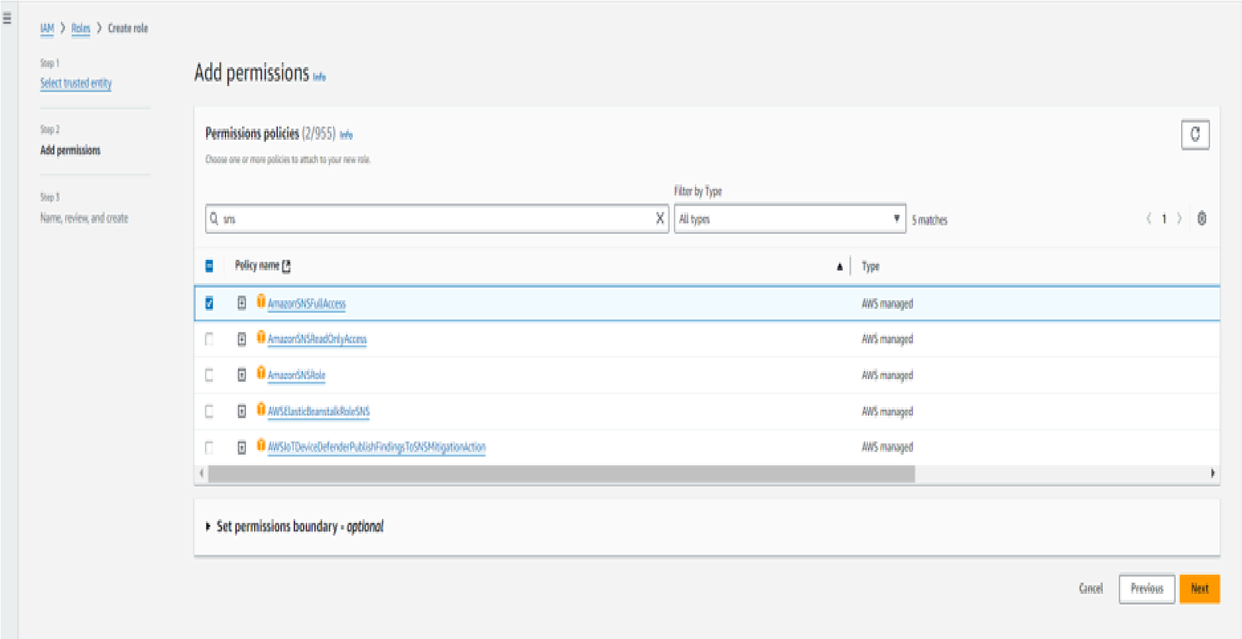

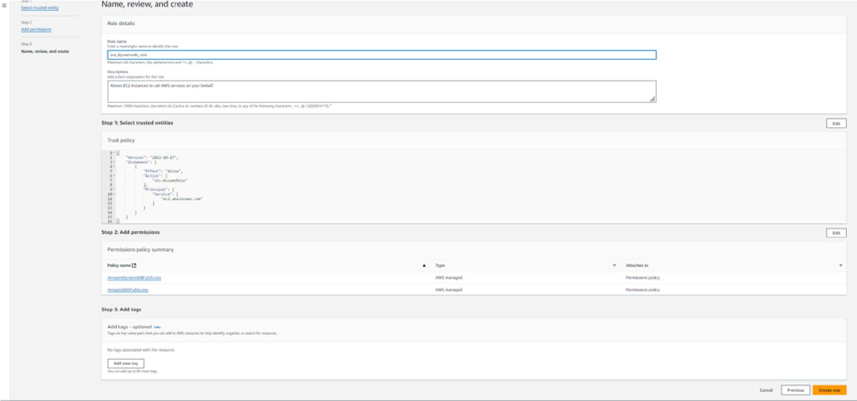

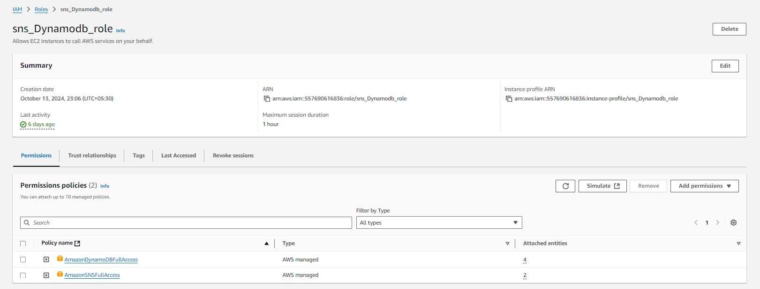

# Milestone 6: EC2 Instance Setup

● **Note: Load your Flask app and Html files into GitHub repository.**

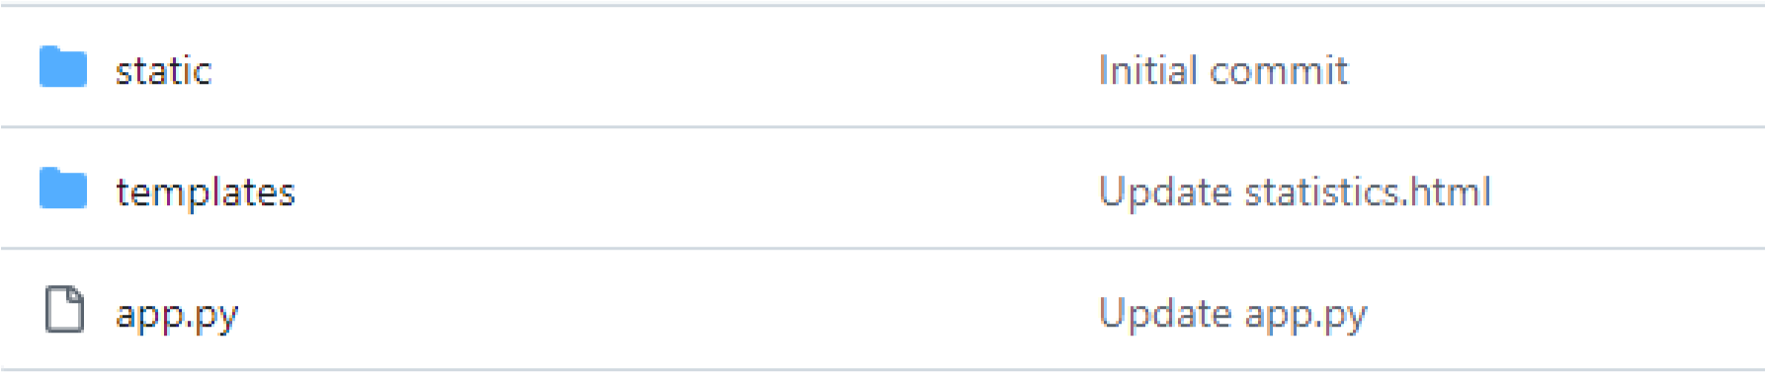

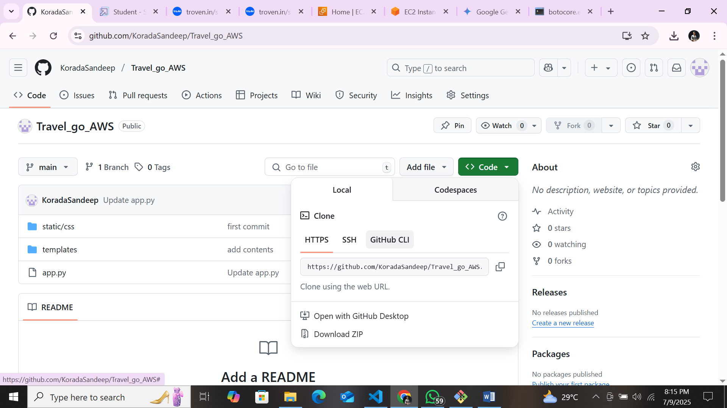

### ● Activity 6.1: Launch an EC2 instance to host the Flask application.

### ● Launch EC2 Instance

○ In the AWS Console, navigate to EC2 and launch a new instance.

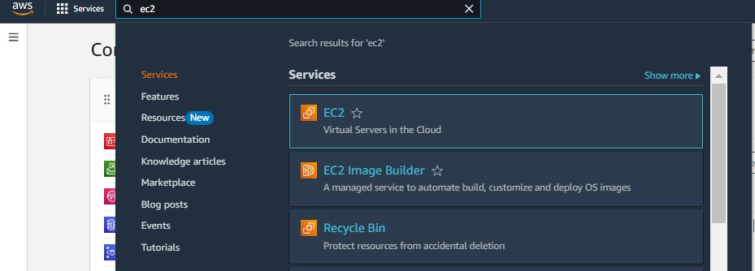

* Click on Launch instance to launch EC2 instance

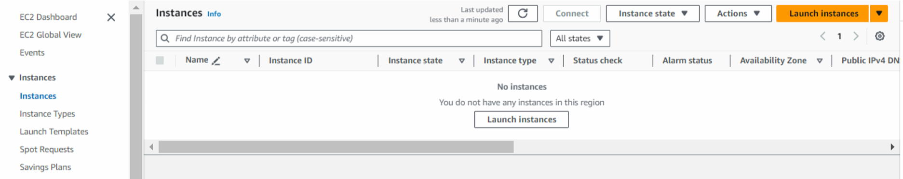

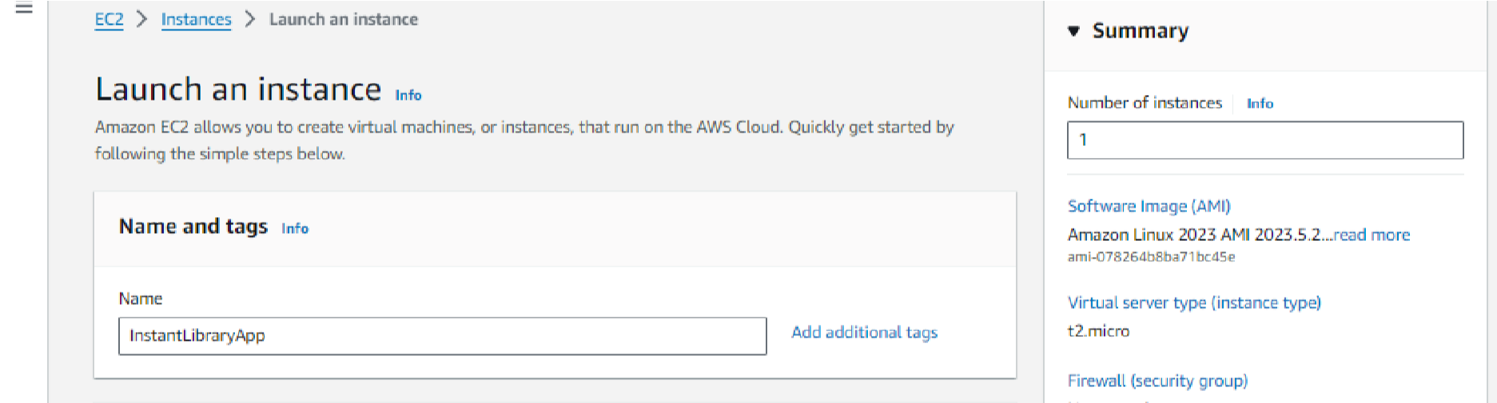

* Choose Amazon Linux 2 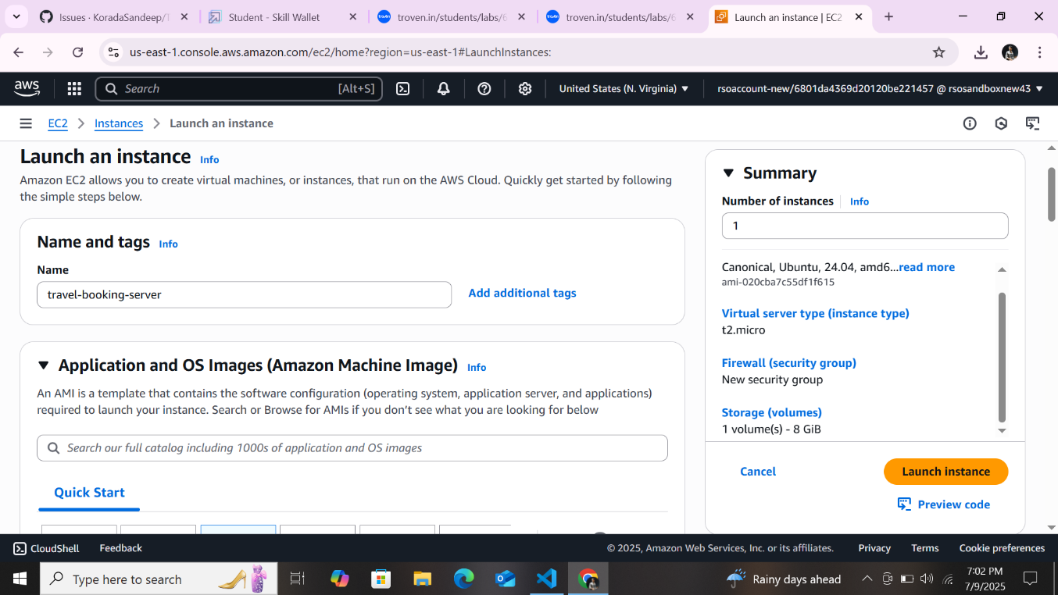or Ubuntu as the AMI and t2.micro as the instance type (free-tier eligible).

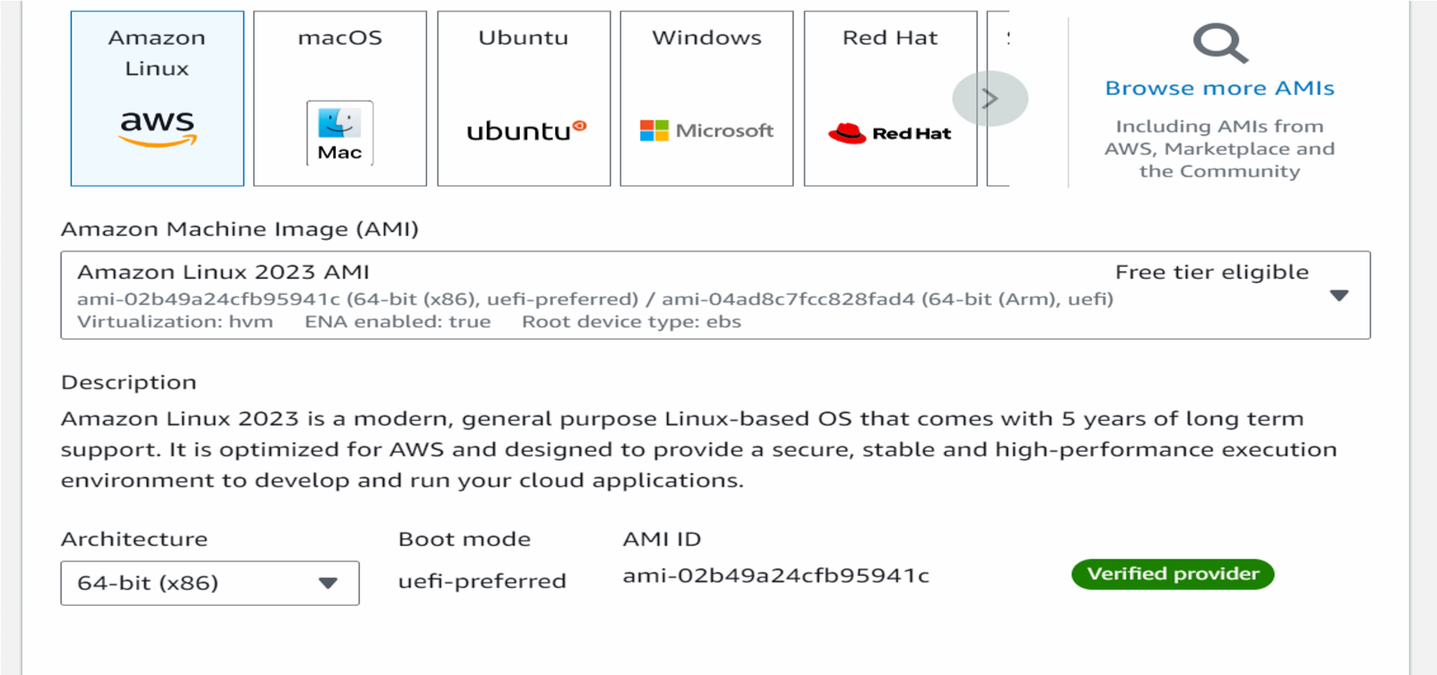

* Create and download the key pair for Server access.

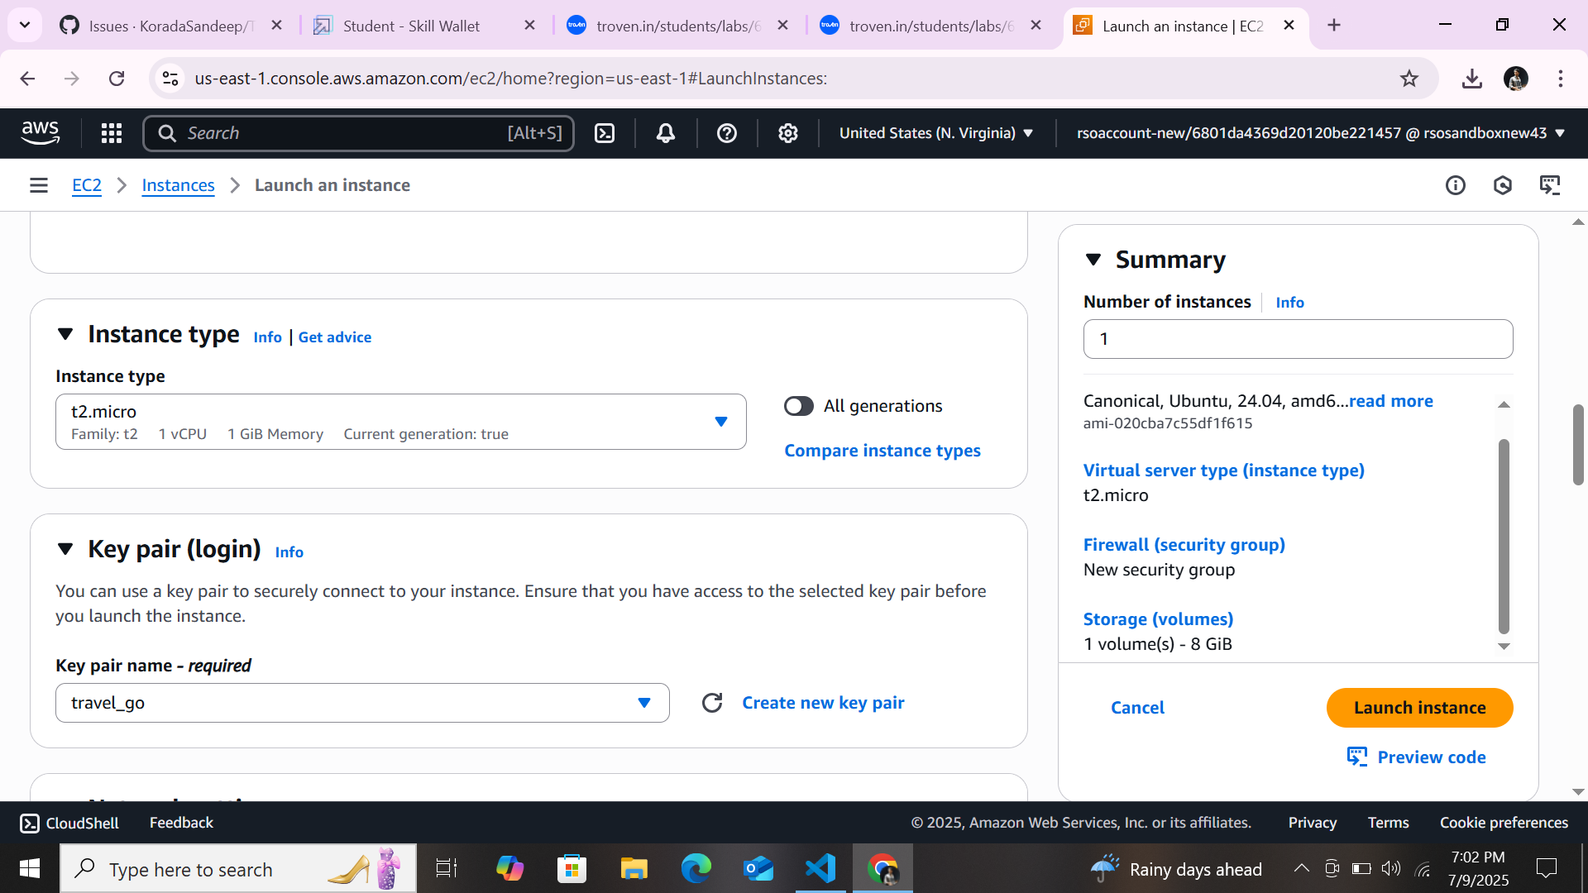

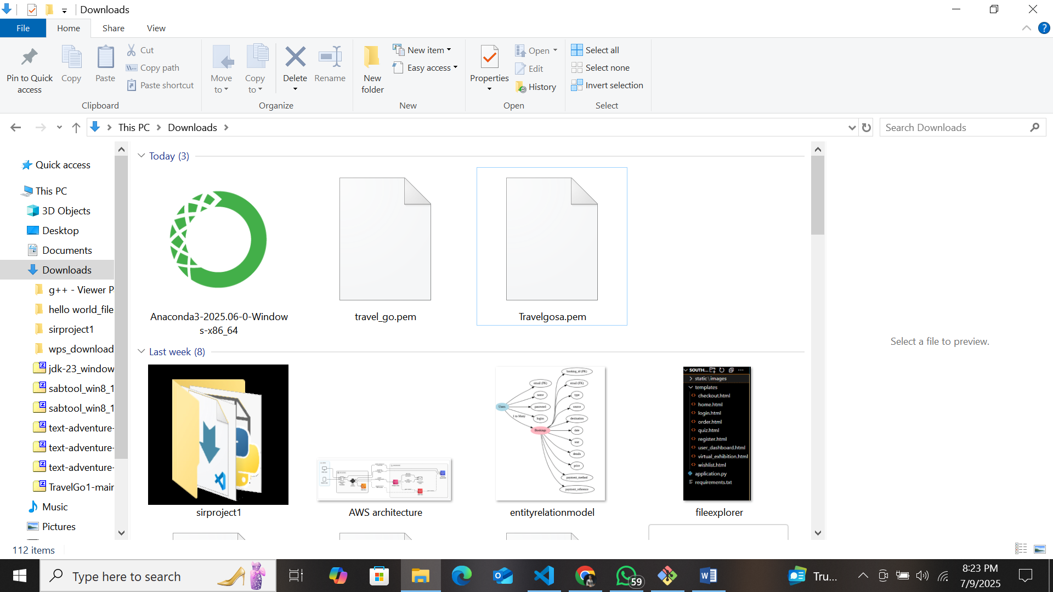

### ● Activity 6.2:Configure security groups for HTTP, and SSH access.

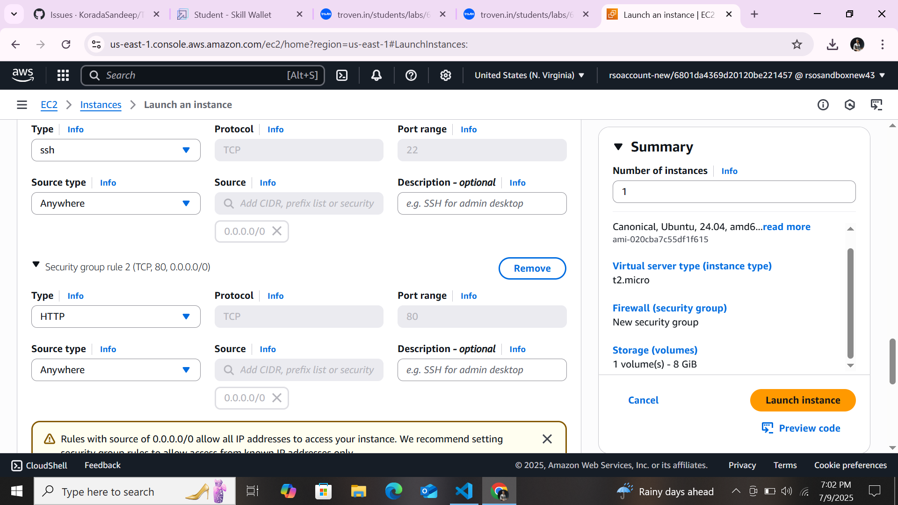

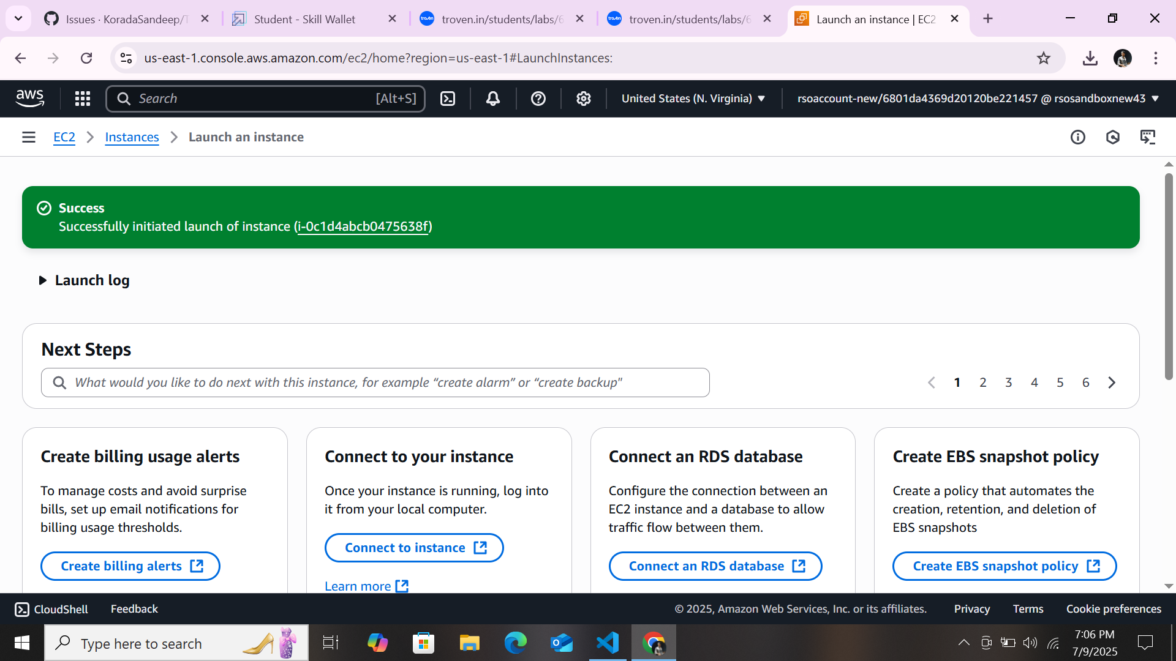

* To connect to EC2 using **EC2 Instance Connect**, start by ensuring that an **IAM role** is attached to your EC2 instance. You can do this by selecting your instance, clicking on **Actions**, then navigating to **Security** and selecting **Modify IAM Role** to attach the appropriate role. After the IAM role is connected, navigate to the **EC2** section in the **AWS Management Console**. Select the **EC2 instance** you wish to connect to. At the top of the **EC2 Dashboard**, click the **Connect** button. From the connection methods presented, choose **EC2 Instance Connect**. Finally, click **Connect** again, and a new browser-based terminal will open, allowing you to access your EC2 instance directly from your browser.

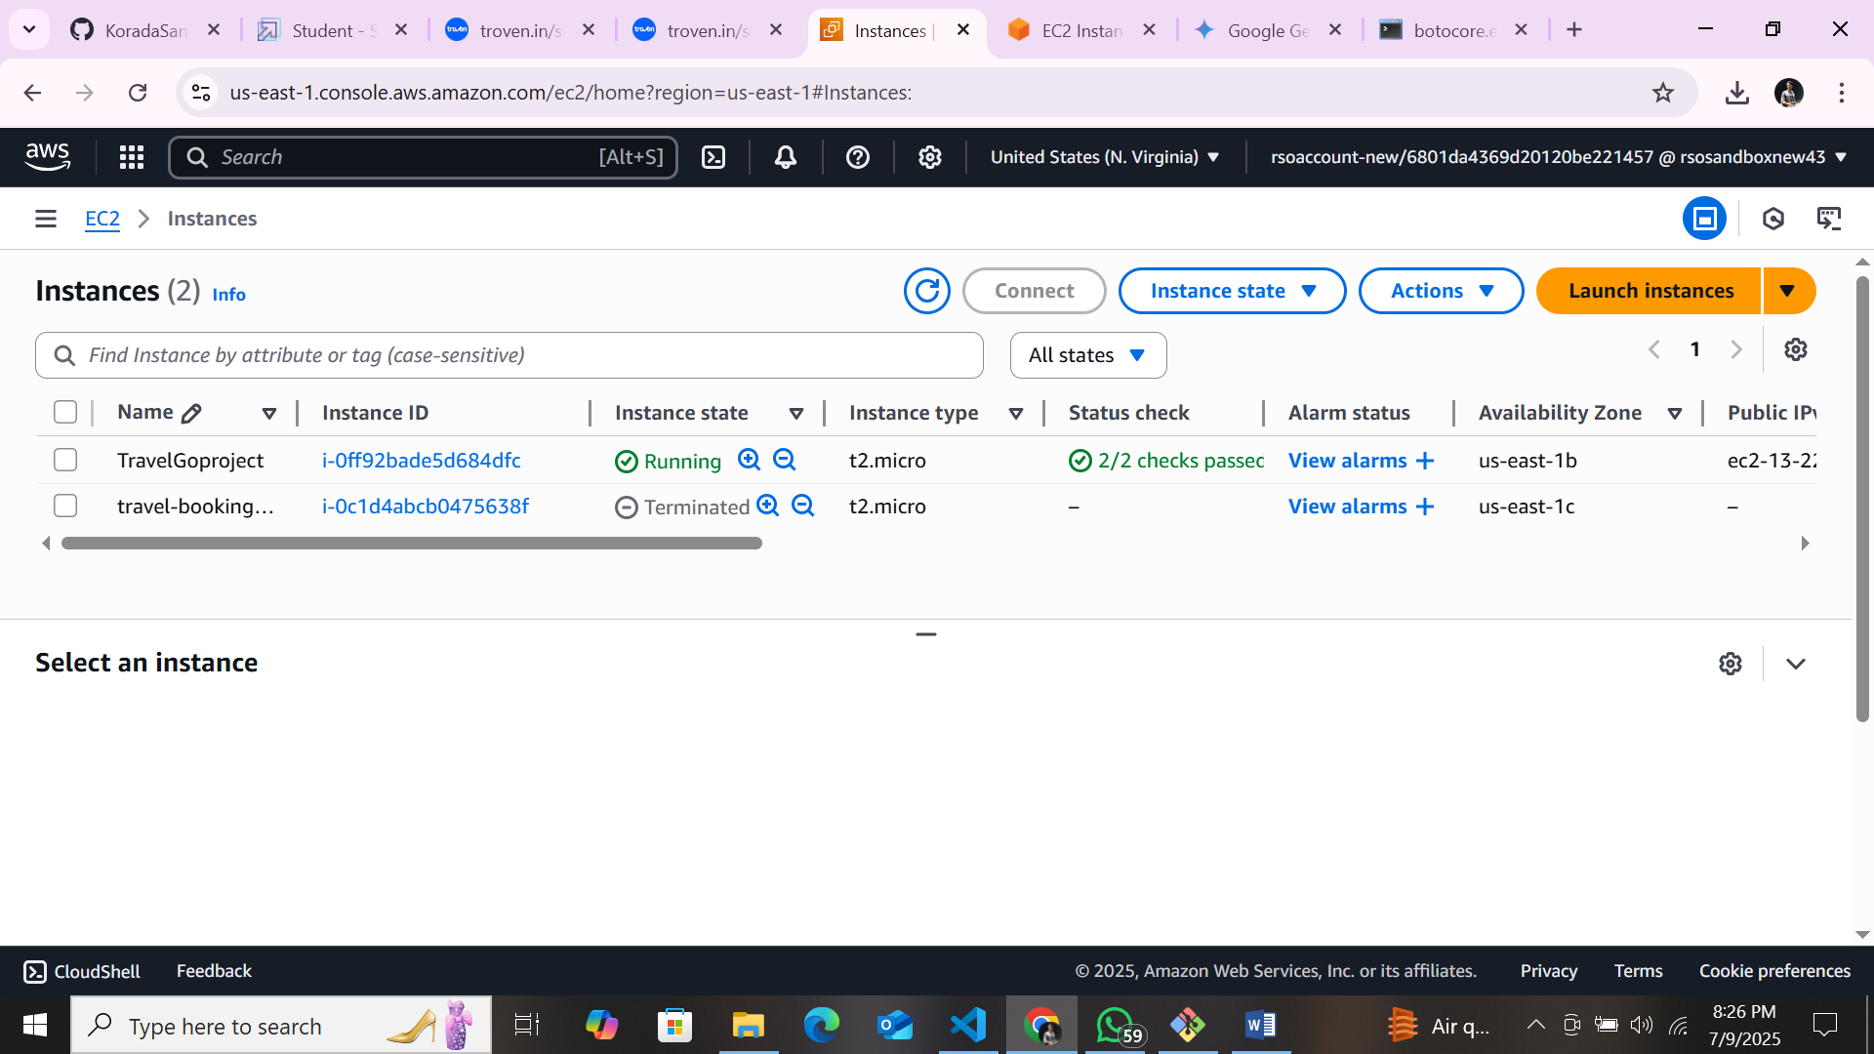

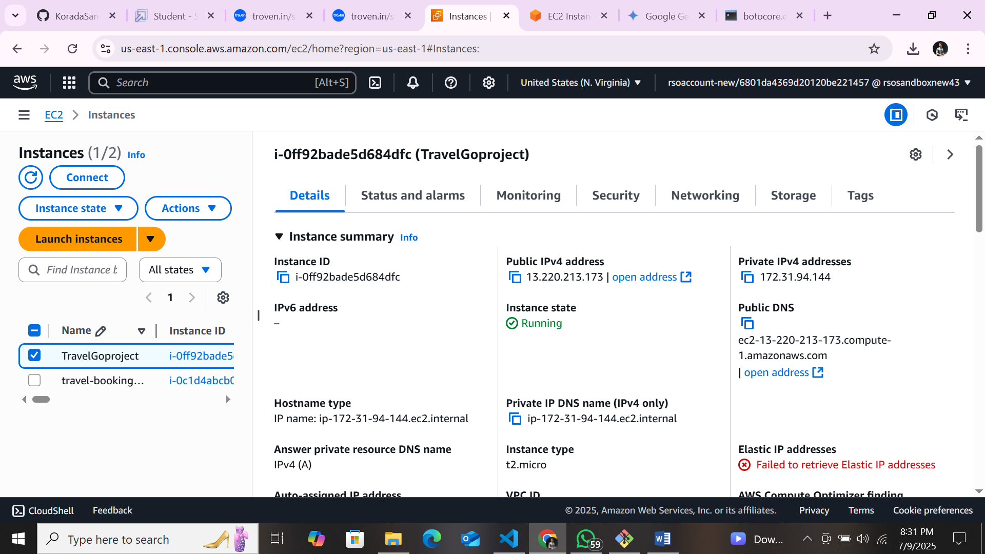

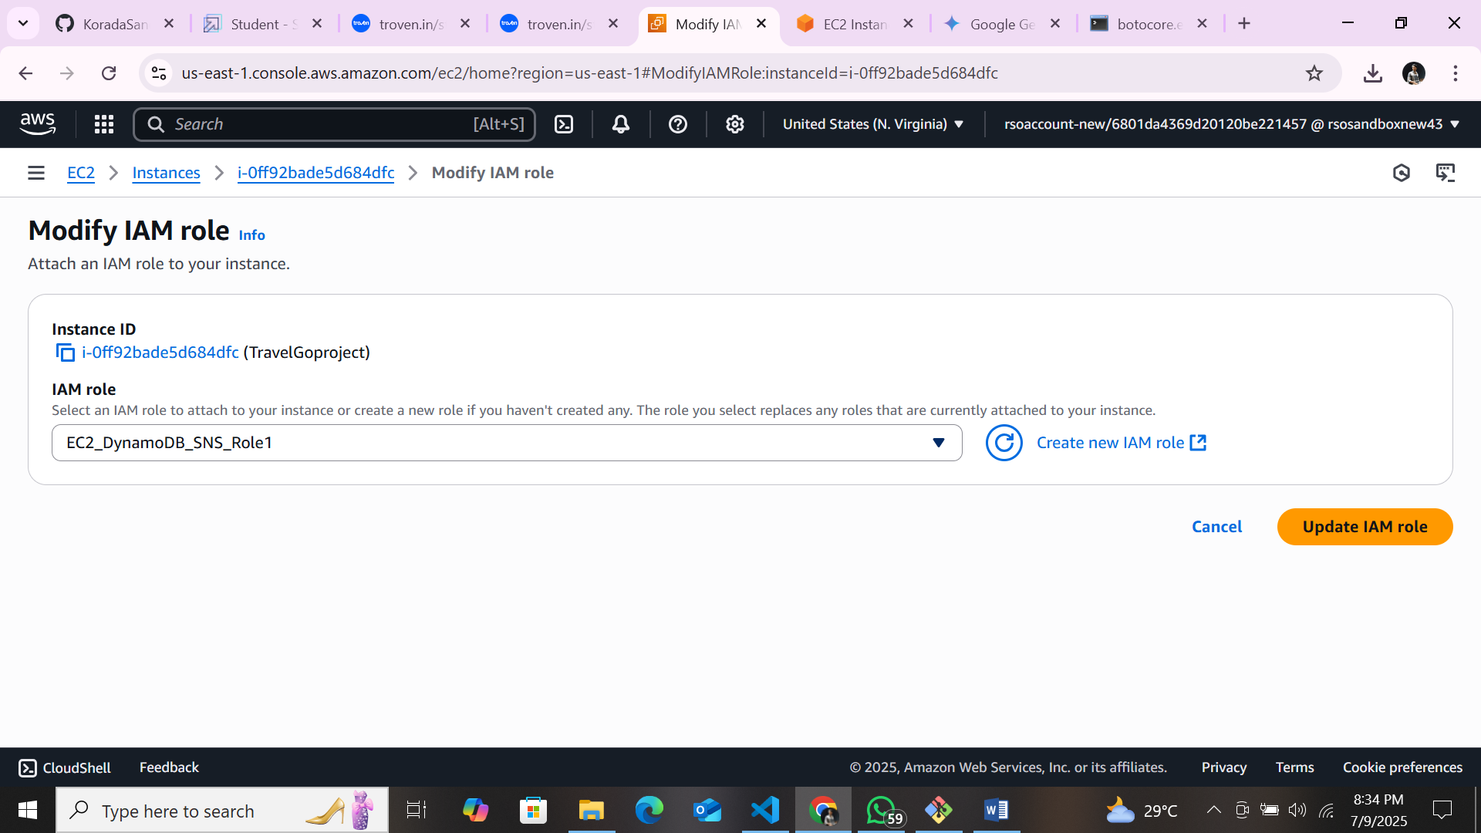

* Now connect the EC2 with the files

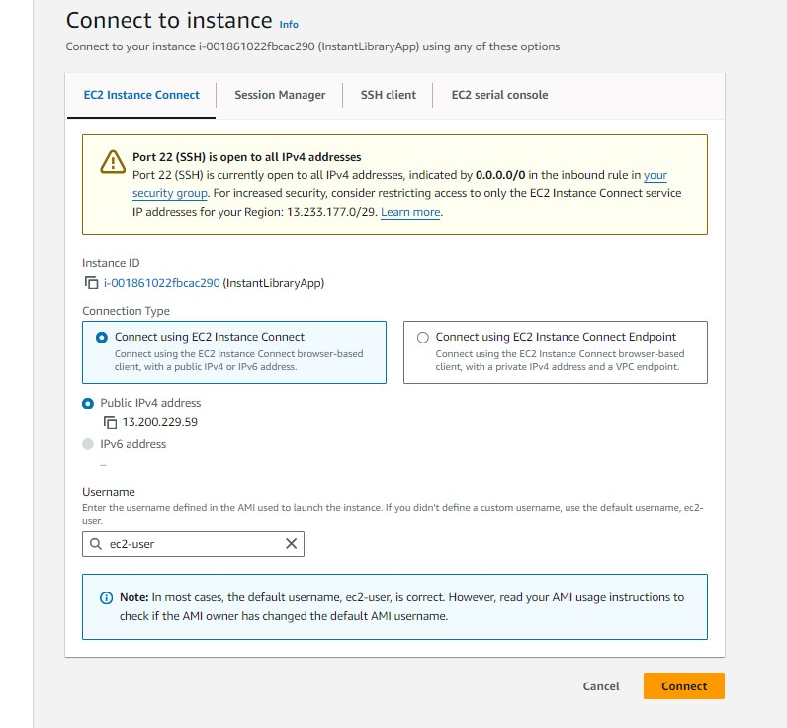

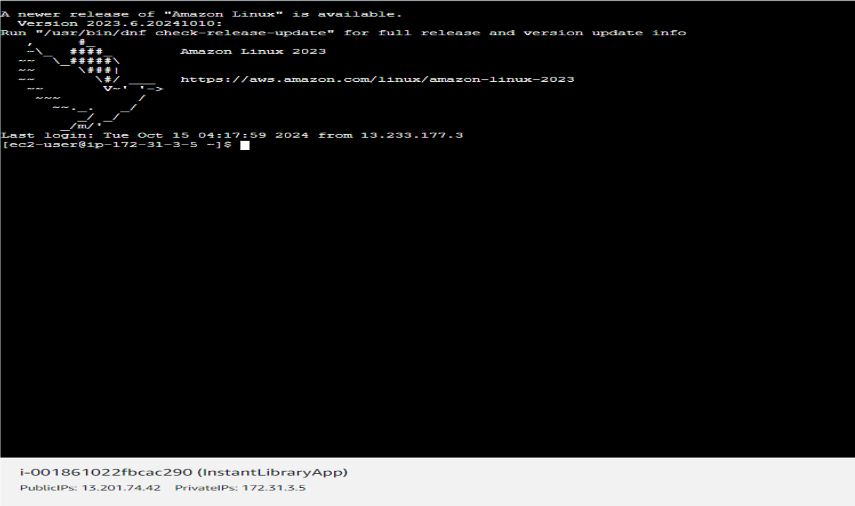

# Milestone 7: Deployment on EC2

### Activity 7.1: Install Software on the EC2 Instance

Install Python3, Flask, and Git:

On Amazon Linux 2: sudo yum update -y

sudo yum install python3 git sudo pip3 install flask boto3

Verify Installations:

flask --version git --version

### Activity 7.2:Clone Your Flask Project from GitHub

**Clone your project repository from GitHub into the EC2 instance using Git.**

Run: ‘git clone <https://github.com/your-github-username/your-repository-name.git>’ Note: change your-github-username and your-repository-name with your credentials here: ‘git clone https://github.com/AlekhyaPenubakula/InstantLibrary.git’ ● This will download your project to the EC2 instance.

### To navigate to the project directory, run the following command:

cd InstantLibrary

### Once inside the project directory, configure and run the Flask application by executing the following command with elevated privileges:

### Run the Flask Application

sudo flask run --host=0.0.0.0 --port=80

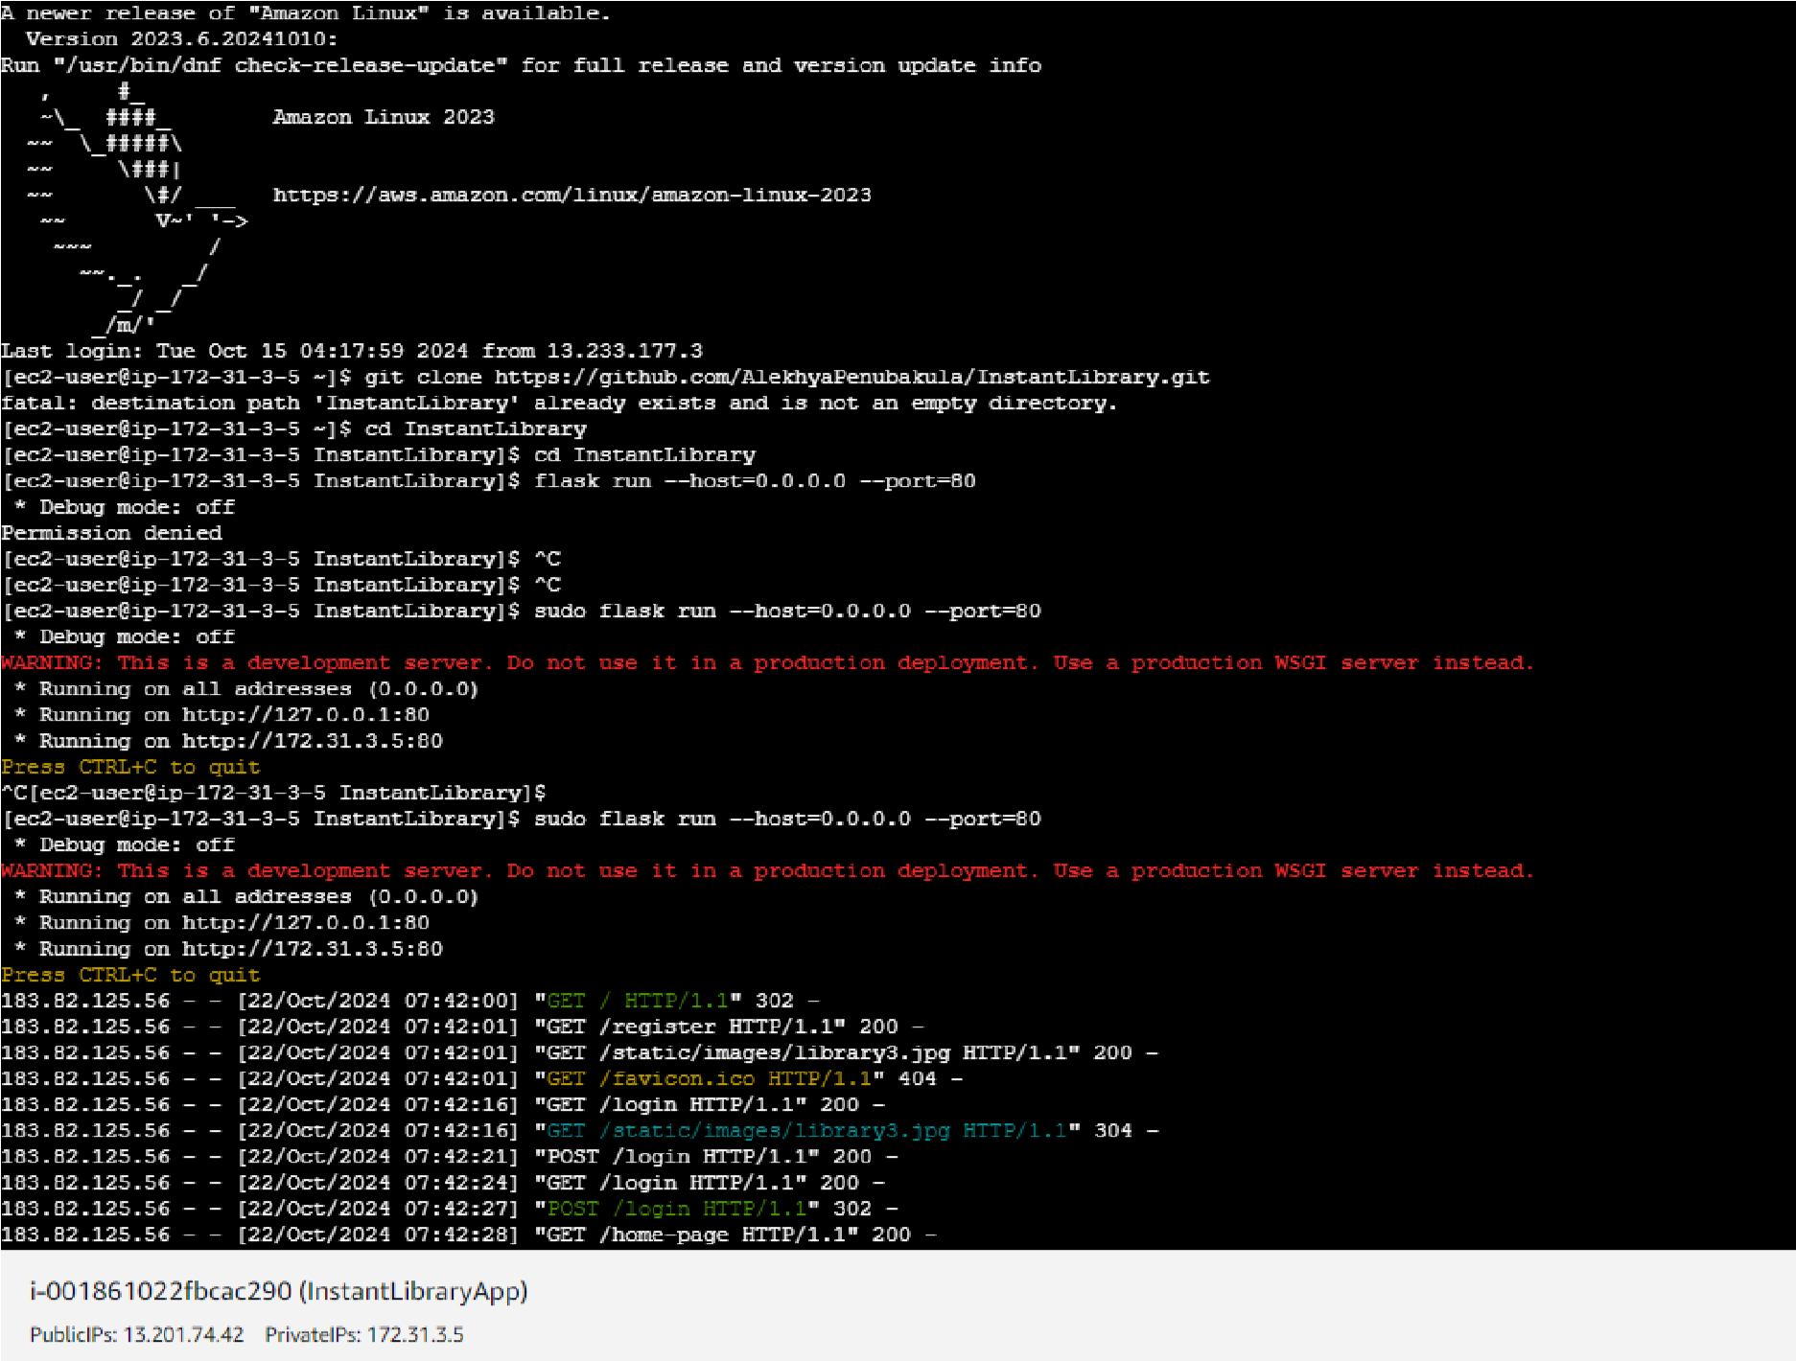

### Verify the Flask app is running: http://your-ec2-public-ip

○ Run the Flask app on the EC2 instance

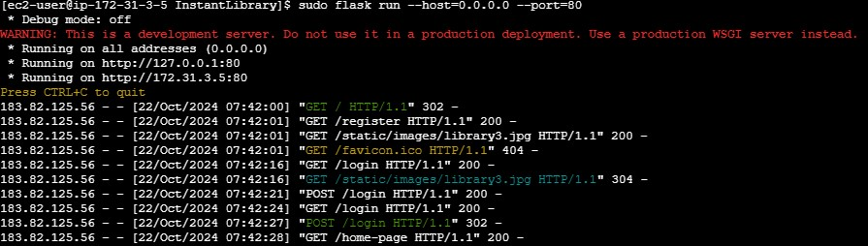

### Access the website through:

**PublicIPs: http:54.221.143.23:5000**

## Milestone 8: Testing and Deployment

### ● Activity 8.1: Conduct functional testing to verify user registration, login, book requests, and notifications.

**Login Page:**

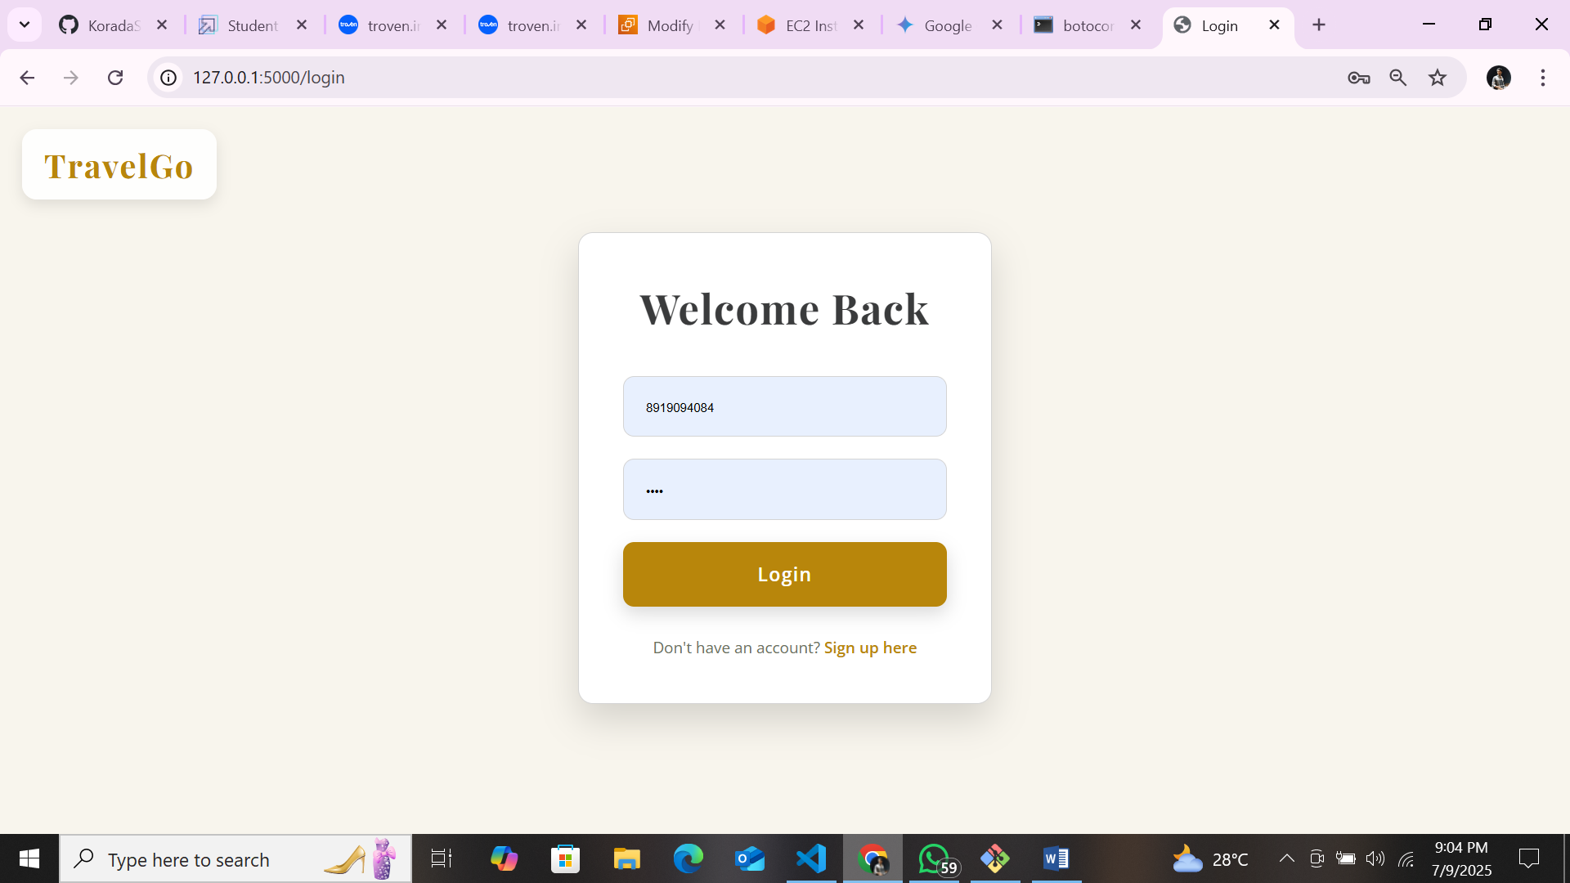

**Register Page:**

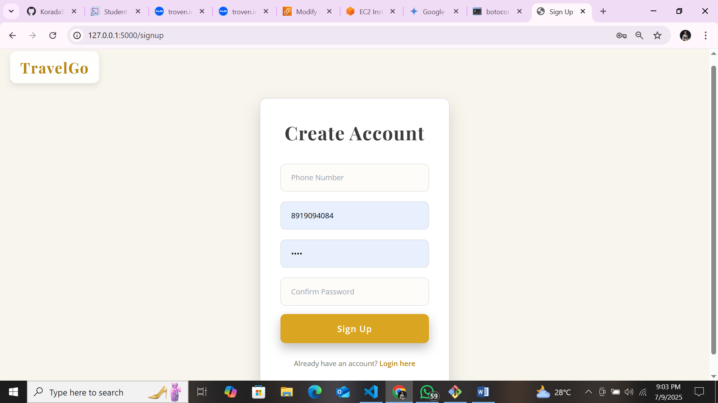

**Home page:**

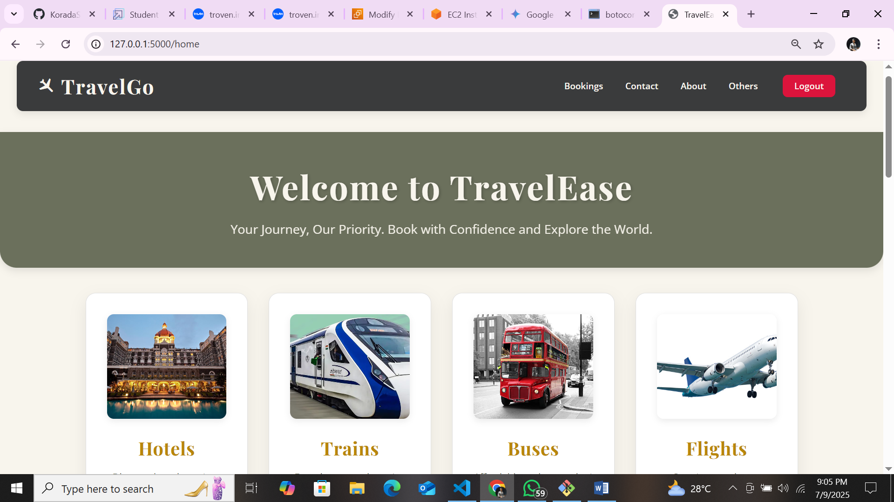

**About Bookings page:**

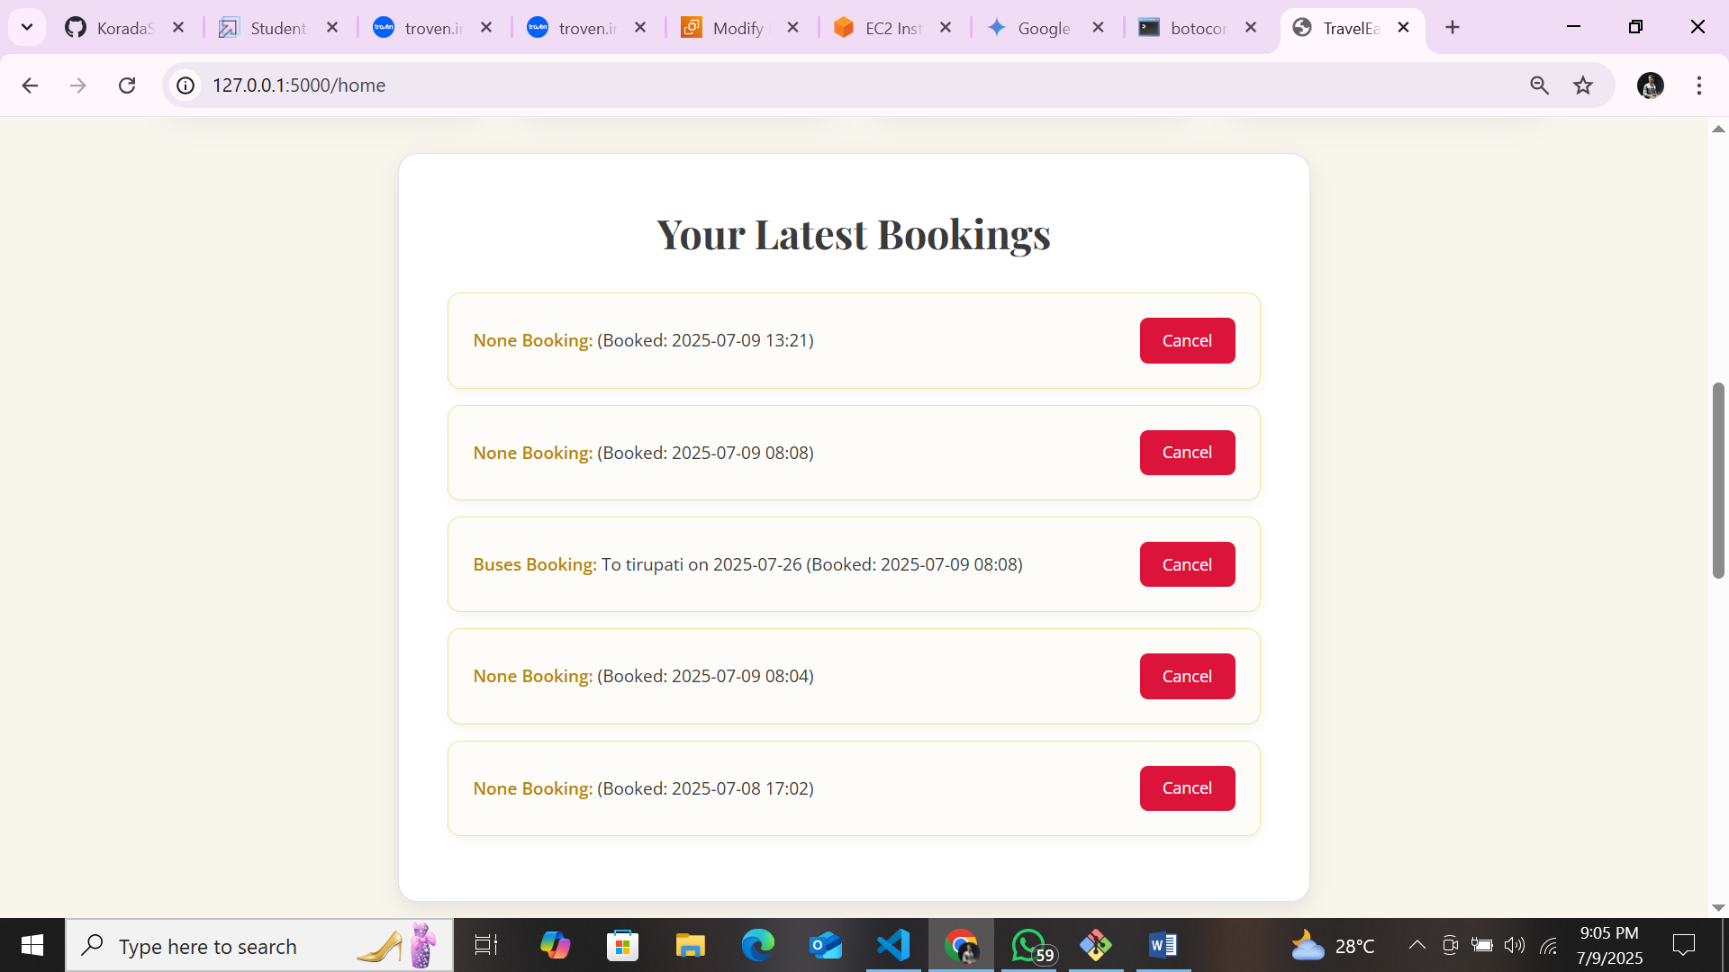

**Contact Page:**

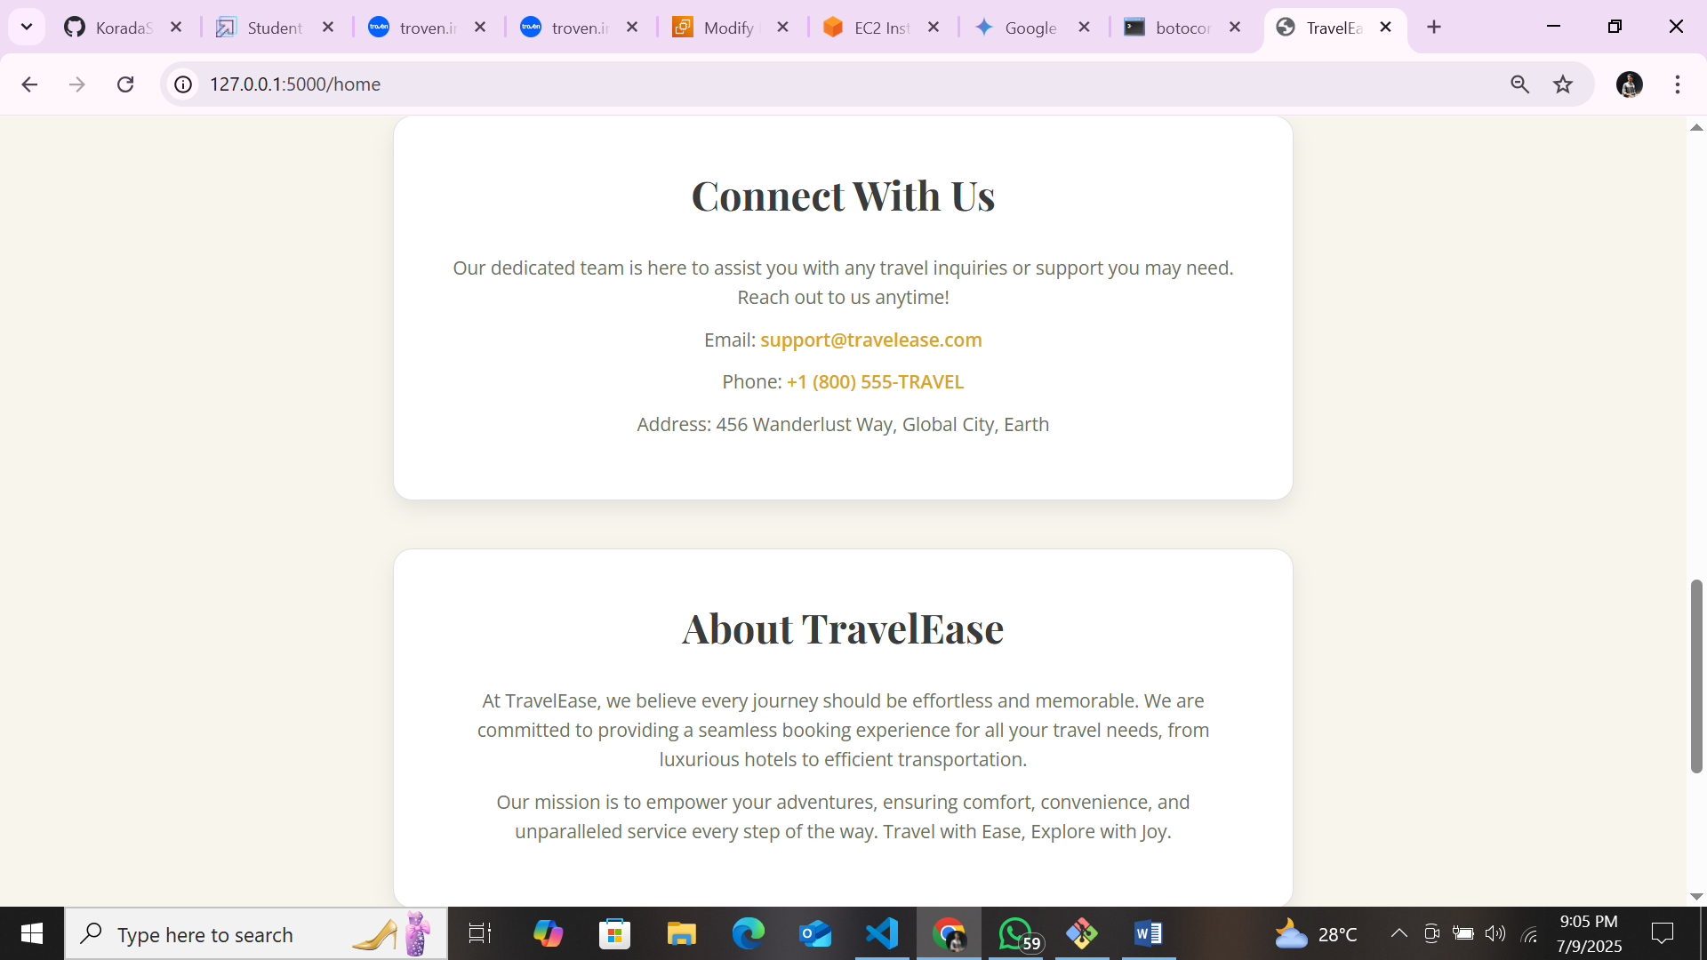

**About page:**



**Hotels Booking :**

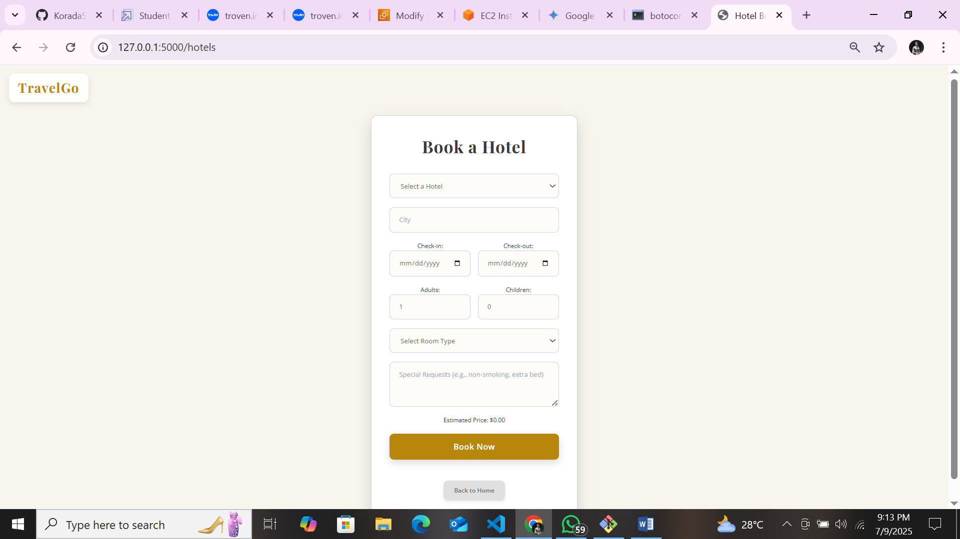

**Trains Booking:**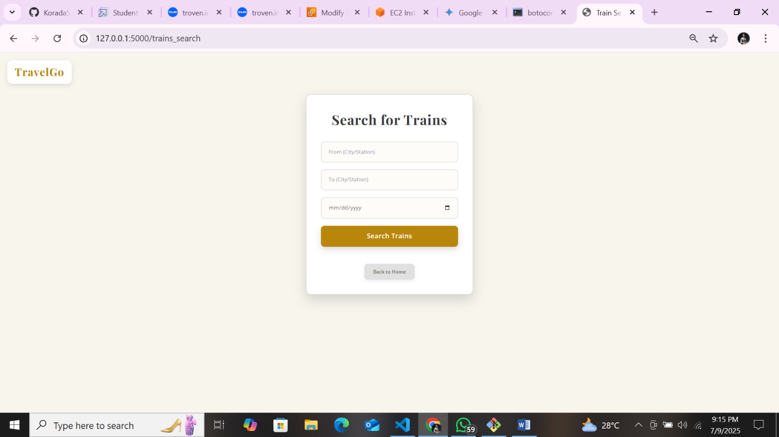

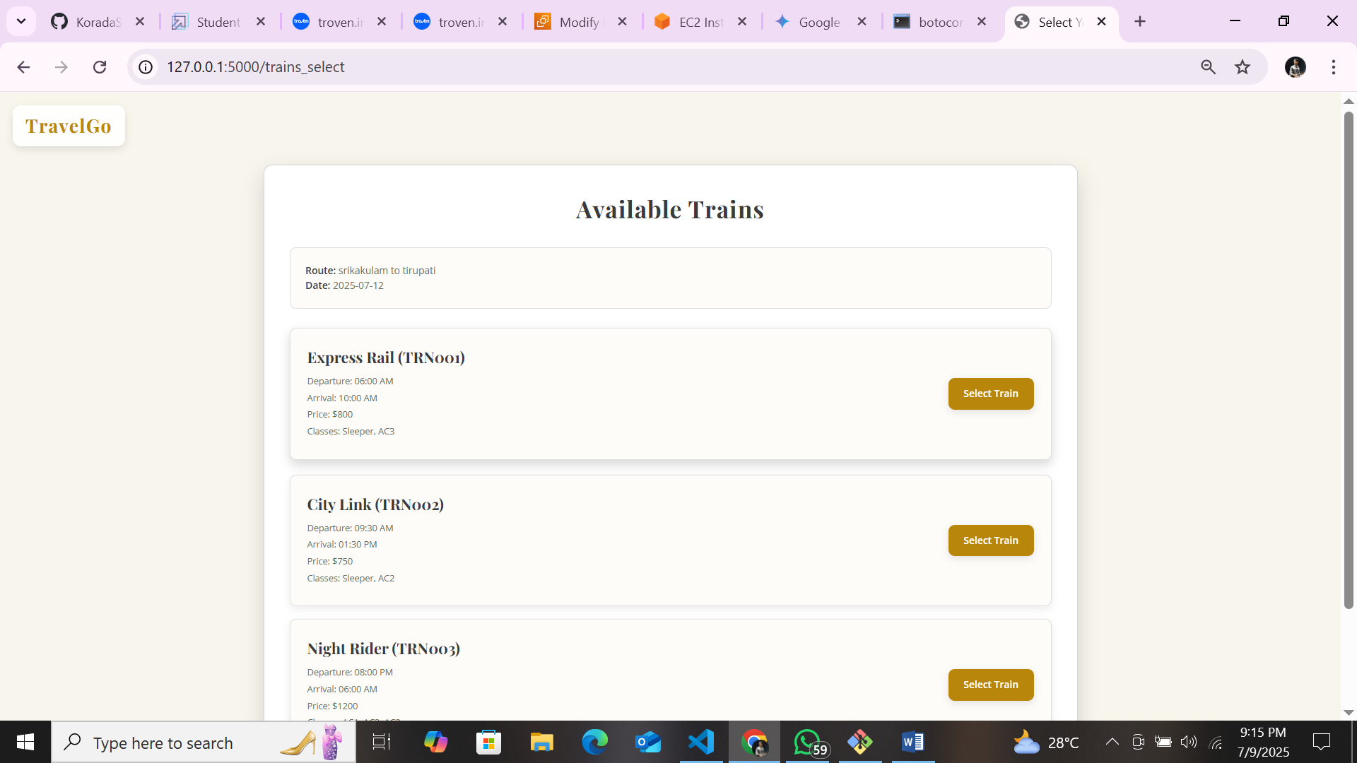

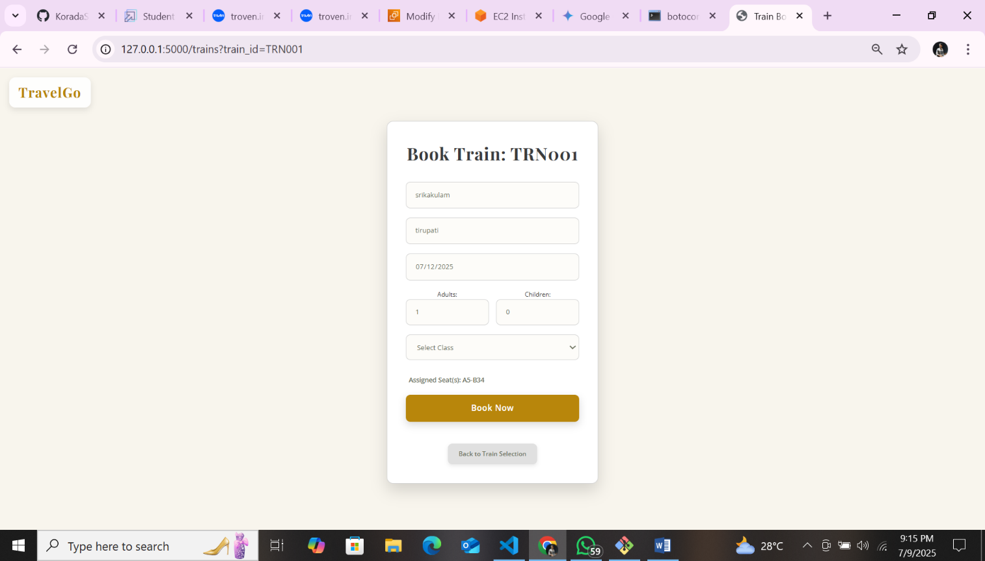

**Buses Booking:**

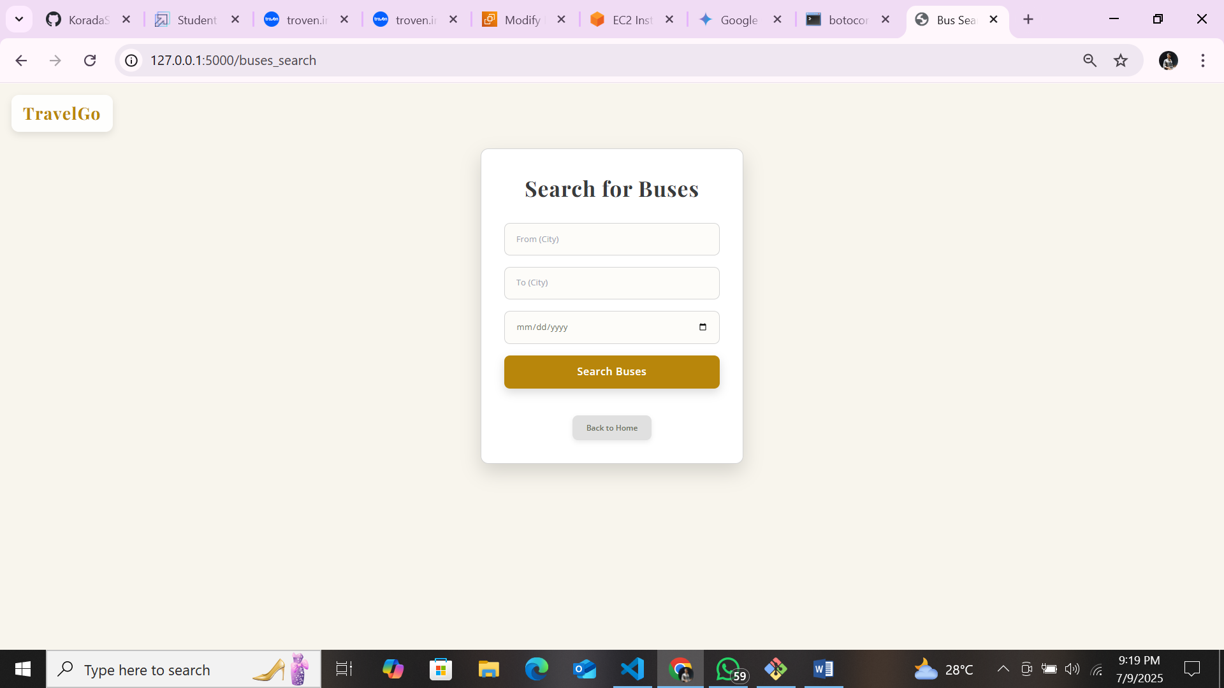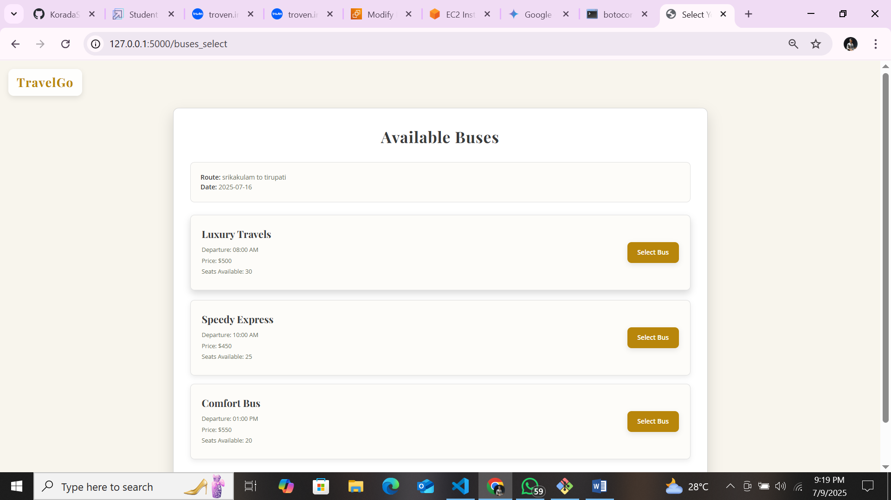

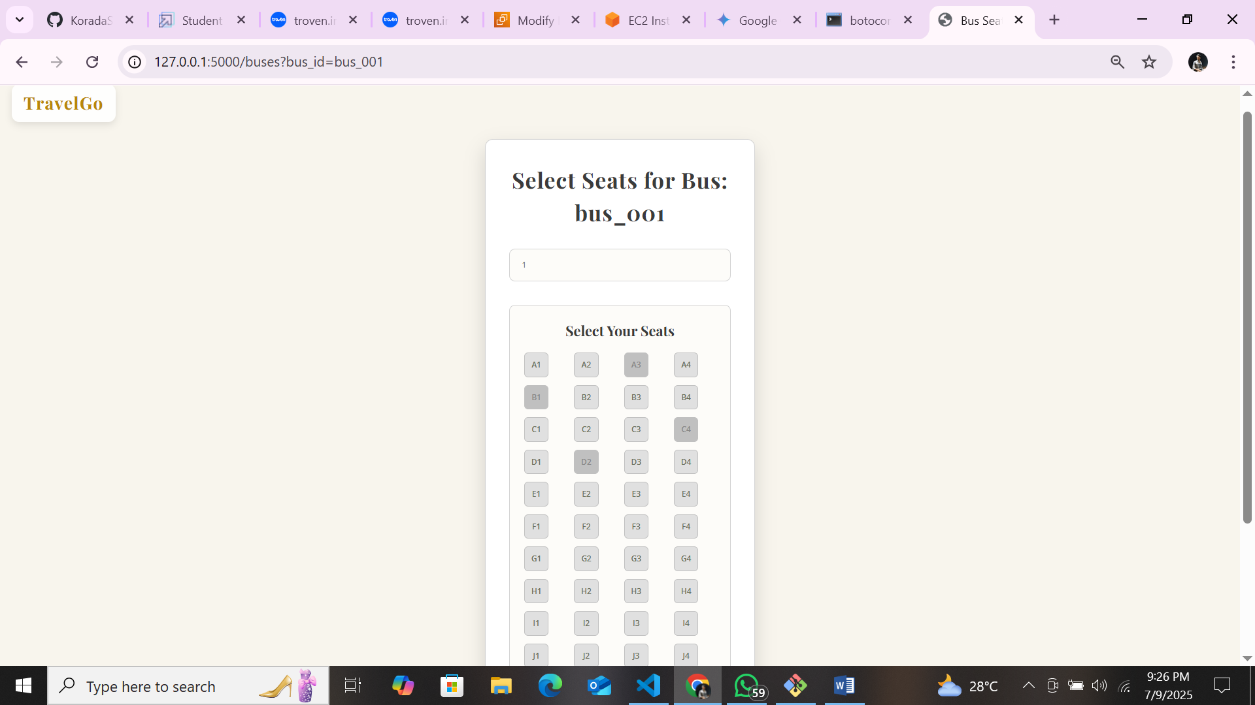

**Flights Booking:**

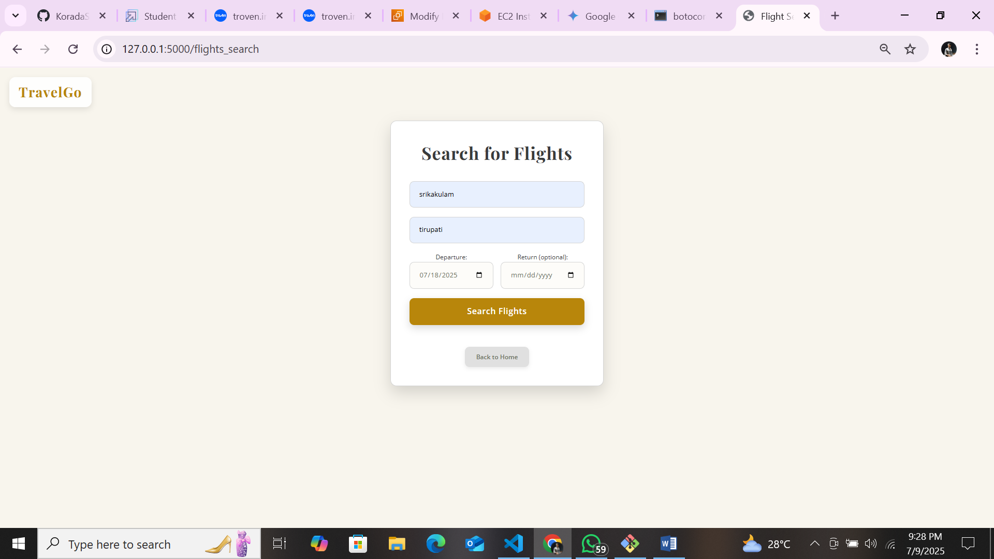

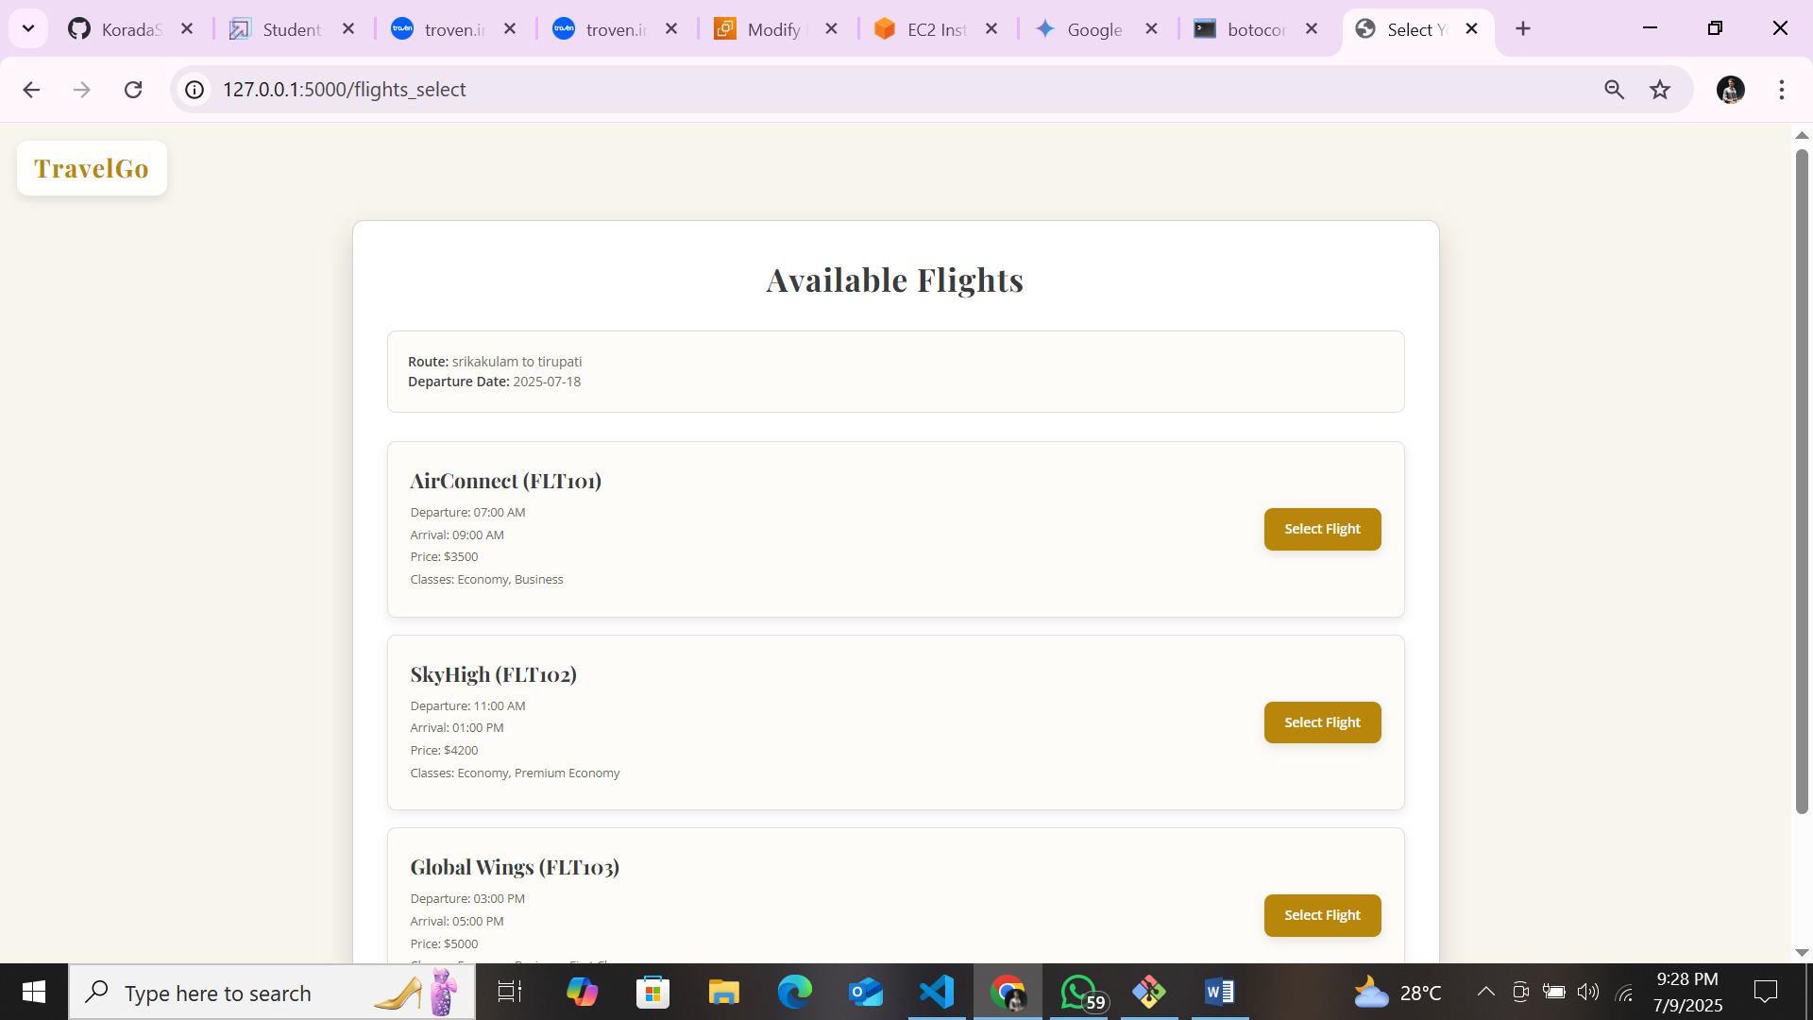

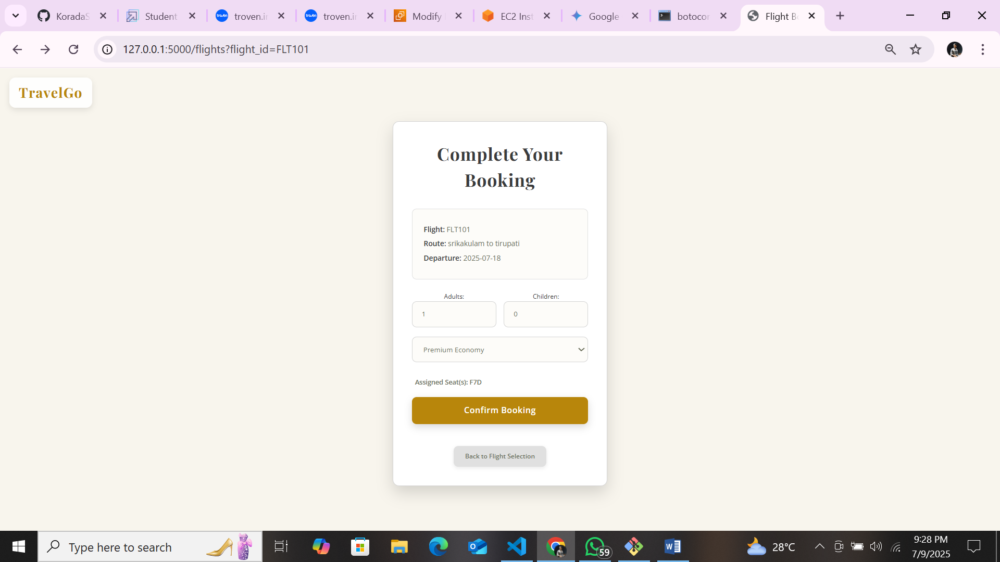

# Conclusion:

The TravelGo Website has been successfully developed and deployed using a scalable and cloud-native architecture. Leveraging AWS services such as EC2 for hosting, DynamoDB for real-time data management, and SNS for instant booking and cancellation notifications, the platform provides a seamless travel booking experience for users. TravelGo enables registered users to search and book buses, trains, flights, and hotels in a centralized, intuitive interface, eliminating the complexities of navigating multiple travel services.

The cloud infrastructure ensures high availability and smooth performance even during peak usage, while the Flask backend ensures efficient handling of user authentication, dynamic booking flows, and data transactions. Real-time notification integration via AWS SNS allows users to receive booking confirmations and cancellations immediately via email, improving communication and user engagement.

In summary, the TravelGo Website offers a modern, reliable, and user-friendly solution for managing travel and accommodation needs. It highlights the potential of cloud-based platforms in building unified travel systems, simplifying operations, and enhancing the overall user experience.